ANNUAL REPORT BOOK

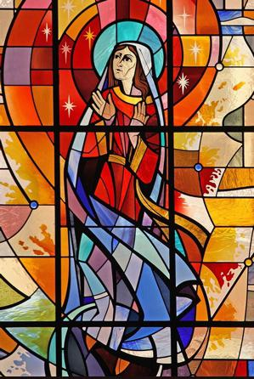
HAMILTON
DIOCESAN
COUNCIL

2021

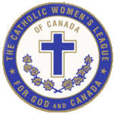
_____________________________________________________________________________
Hamilton Diocesan Council
Of
The Catholic Women’s League of Canada

Care for Our Common Home
Table of Contents

MESSAGES
Most Reverend Douglas Crosby, Bishop of Hamilton………………………...5
Reverend Larry Parent, Diocesan Spiritual Advisor…………………………….6
Colleen Perry, Provincial President…………………………………………...........7
Joyce Cotter, Diocesan President………………………………………………………….8

BOOK OF LIFE ……………………………………………………………………….. 9

DIOCESAN OFFICERS AND COMMITTEE REPORTS
Diocesan Council Executive……………………………………………………………….. 15
Past President/Historian…………………………………………………………………….. 16
Secretary…………………………………………………………………………………………….. 19
Treasurer…………………………………………………………………………………………….. 21

DIOCESAN COMMITTEE REPORTS
Spiritual Development ……………………………………………………………………….. 24
Organization………………………………………………………………………………………… 26
Christian Family Life……………………………………………………………………………. 28
Communications...………………………………………………………………………………. 31
Community Life....…….………………………………………………………………………… 33
Education & Health……………………………………………………………………………… 35 Resolutions………………………………………………………………………………………….. 37
Legislation……………………………………………………………………………………………. 38

Life Member Liaison……..………………………………………………………………………40

REGIONAL REPORTS
Brant……………………………………………………………………………………………………..46
Hamilton………………………………………………………………………………………………..47
Kitchener……………………………………………………………………………………………….54
North………………………………………………………………………………………………………62

SPECIAL MENTIONS
Frances Lovering Woman of the Year Award……………………………………….

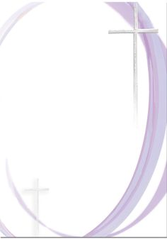

THE LEAGUE PRAYER

We humbly prayer You, O God our Father, to bless The Catholic Women’s League of Canada.

Bless our beloved country, our homes and families.

Send Your Holy Spirit upon us to give light to our minds and strength to our wills that we may know and fulfil Your great law of charity. Teach us to share with others at home and abroad, the good things You have given us.

This we ask through our Lord Jesus Christ and the intercession of Our Patroness, Our Lady of Good Counsel.

Amen.

League Promise

For the glory of God and the good of God’s people,
I promise as a Catholic woman to honour, invoke and imitate our patroness, Our Lady of Good Counsel.
I promise to be a loyal member of
The Catholic Women’s League of Canada
And to promote its interest and growth in every way.
I promise to cooperate with officers in all programs under their direction and to conform to the best of my ability to the bylaws of the organization in all League activities.

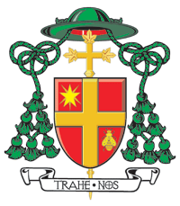

B I S H O P O F H A M I L T O N

April 25, 2022

Dear President Joyce Cotter and members of the Diocesan Council of the Catholic Women’s League of Canada,

The report of the many good works of the members of the Catholic Women’s League in the Diocese of Hamilton is testimony of your commitment to Jesus Christ and his commands to welcome the “little one” whom he identified as his sister and brother!

Congratulations on completing another year of service “to God and Canada”! I am grateful for your good works in many of the parishes in the Diocese.

Thank you also to Father Larry Parent, Diocesan Spiritual Advisor, for his wise counsel and dedicated support of the League throughout the Diocese.

May these “acts” inspire young women to join the League and continue its good works for the good of the Diocese and beyond.

Sincerely in the Risen Christ and Mary Immaculate,

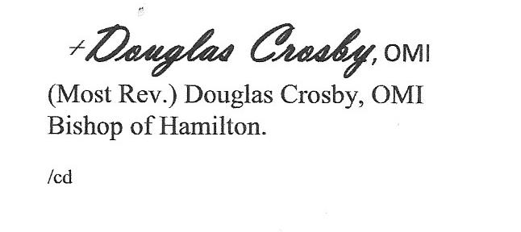

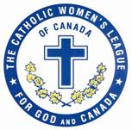
The Hamilton Diocesan Catholic Women’s League of Canada

Dear Members of the Catholic Women’s League of Canada,
2021 was a strange year in the thick of the pandemic, when so much of our meeting and gathering was done virtually, on-line.
Our 2021 convention was simply done in front of cameras and live streamed out to the membership.
Most of the information from the diocese (chancery) concerned protocols for best practices in our parishes. Thank God we are not so protocol heavy now! Let’s pray that we continue to come out of this pandemic gracefully.
If nothing else, my greatest lesson from the League was the dedication of the Executive to continue to meet with virtual chats, and support each other through social media and to pray for each other, especially when personal concerns and needs were expressed. That kind of dedication, encouraged me in my dedication to the parish I serve.
The Indigenous residential school crisis fomented a renewed response to victims by both the government and the churches in Canada, in 2021. The diocesan CWL rose to the call for compassionate awareness, by developing an online workshop series that is offered in 2022 with the hope of developing awareness of the crisis and help us better understand the plight of survivors.
We look forward in hope that the pandemic is diminishing and that we can develop renewed expressions of our Catholic Faith, strengthen our ties of friendship and continue with a vibrant League.
Blessings on the year past and on the year ahead.
In Christ,
Fr. Larry

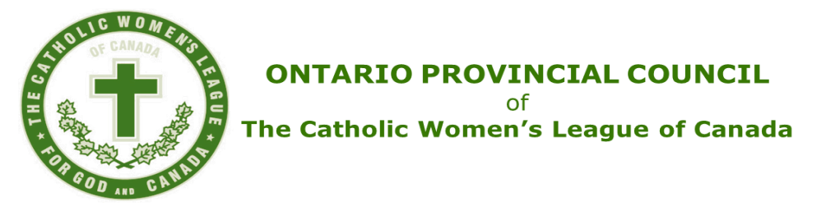

Greetings Members of the Hamilton Diocesan Council,
Change is what we, as Catholic Women’s League members, do so well. We bend and stretch with changing times and attitudes. We learned so many ways of reaching out to each other, our parish family, and the wider community, all the while maintaining physical distancing and wearing our masks. We did this with respect and kindness, mirroring the face of Jesus in all our actions and words.
I am so proud of how you have embraced both the provincial and national themes. You are truly inspirational!
Know that the prayers and best wishes of the almost 35,000 members across Ontario are with you as you gather to conduct the business of your diocesan council for 2022.
You are well represented at the provincial table. Joyce ensures that your diocese has a voice.
Congratulations as you celebrate the 102nd anniversary of the League in your diocese.
May God bless you and Our Lady of Good Counsel watch over you as you continue your humble service in the League, For God and Canada, through faith, service, and social justice.
Respectfully,
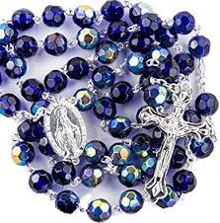
Colleen Perry
Ontario Provincial President

Dear Sisters in the League,
Hamilton Diocesan Council
Of
The Catholic Women’s League of Canada
Care for Our Common Home

It is inspiring to read all the wonderful activities and events that members from The Hamilton Diocesan Council of The Catholic Women’s League of Canada have accomplished this past year.

Our diocesan spiritual theme “Welcome Home’ was incorporated with the national theme “Care for Our Common Home” and the provincial theme “Loneliness” throughout the year.

Councils continued to reach out to the members, sharing their faith and resources with those in need, gathering virtually in prayer and fellowship, participating in parish ministry and supporting their priest.

Members were encouraged to “Sparkle God’s way” as God calls us to be beacons of light for others, and that is shown in these reports submitted by officers and councils.

This annual report book will enrich your spirit of faith and sisterhood – and affirm your sense of belonging and connectedness to our incredible organization of Catholic women. It also illustrates the uniqueness of each council, and the creativity in finding ways to bring hope to others.

I encourage you to read this book cover to cover and reflect on the commitment made by Catholic women throughout the diocese. We have a legacy of 100+ years in the League in Hamilton diocese, be proud of it and celebrate the gifts and talents of our Sisters in the League.

Through the teachings of Jesus and the intercession of Our Lady of Good Counsel, may we achieve holiness of life and sparkle God’s way in our ministry for the League.

Your Sister in the League,

Joyce Cotter
Diocesan President

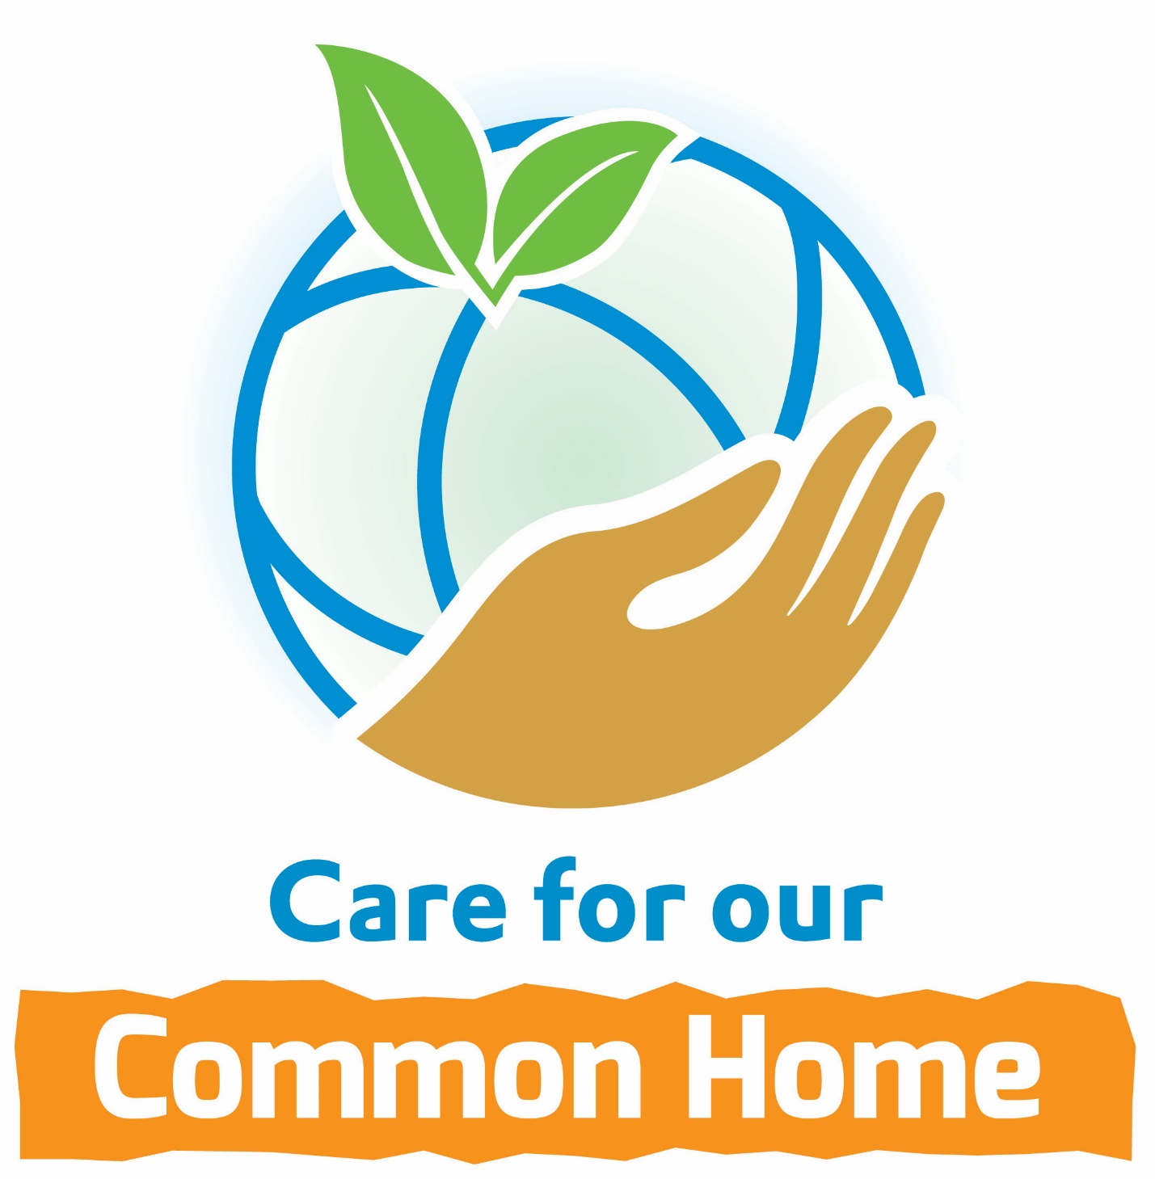

Prayer to Sustain

Lord, season after season,
You continue to renew the face of the earth,
“For from the greatness and beauty of created things
Comes a corresponding perception of their Creator.”

Teach us, Lord,
As members of The Catholic Women’s League of Canada,
To become attuned to our need to protect
The beauty of our common home.

May our efforts lead us to sustain its natural order,
So that, in the words of Pope Francis,
Our heritage is never “deprived of physical contact with nature.”

Prayer for Renewal
God of new beginnings,
ever faithful God, we thank You for
your constant care for the women of The Catholic Women’s
League of Canada. We have sought to serve You in faith by
service to your people.
Under the guidance of the Holy Spirit and with the help of
Our Lady of Good Counsel, we continue to discern Your call to
seek justice and build Your Kingdom on earth each day.
We ask your guidance as we plan the evolution of The Catholic Women’s League of Canada. Grant us wisdom, the grace of discernment, and strength. May each of us open her heart and
mind to the League.
We ask this through Jesus, Your beloved Son and Our Lord,
Who lives and reigns with You and the Holy Spirit, God forever
and ever. AMEN
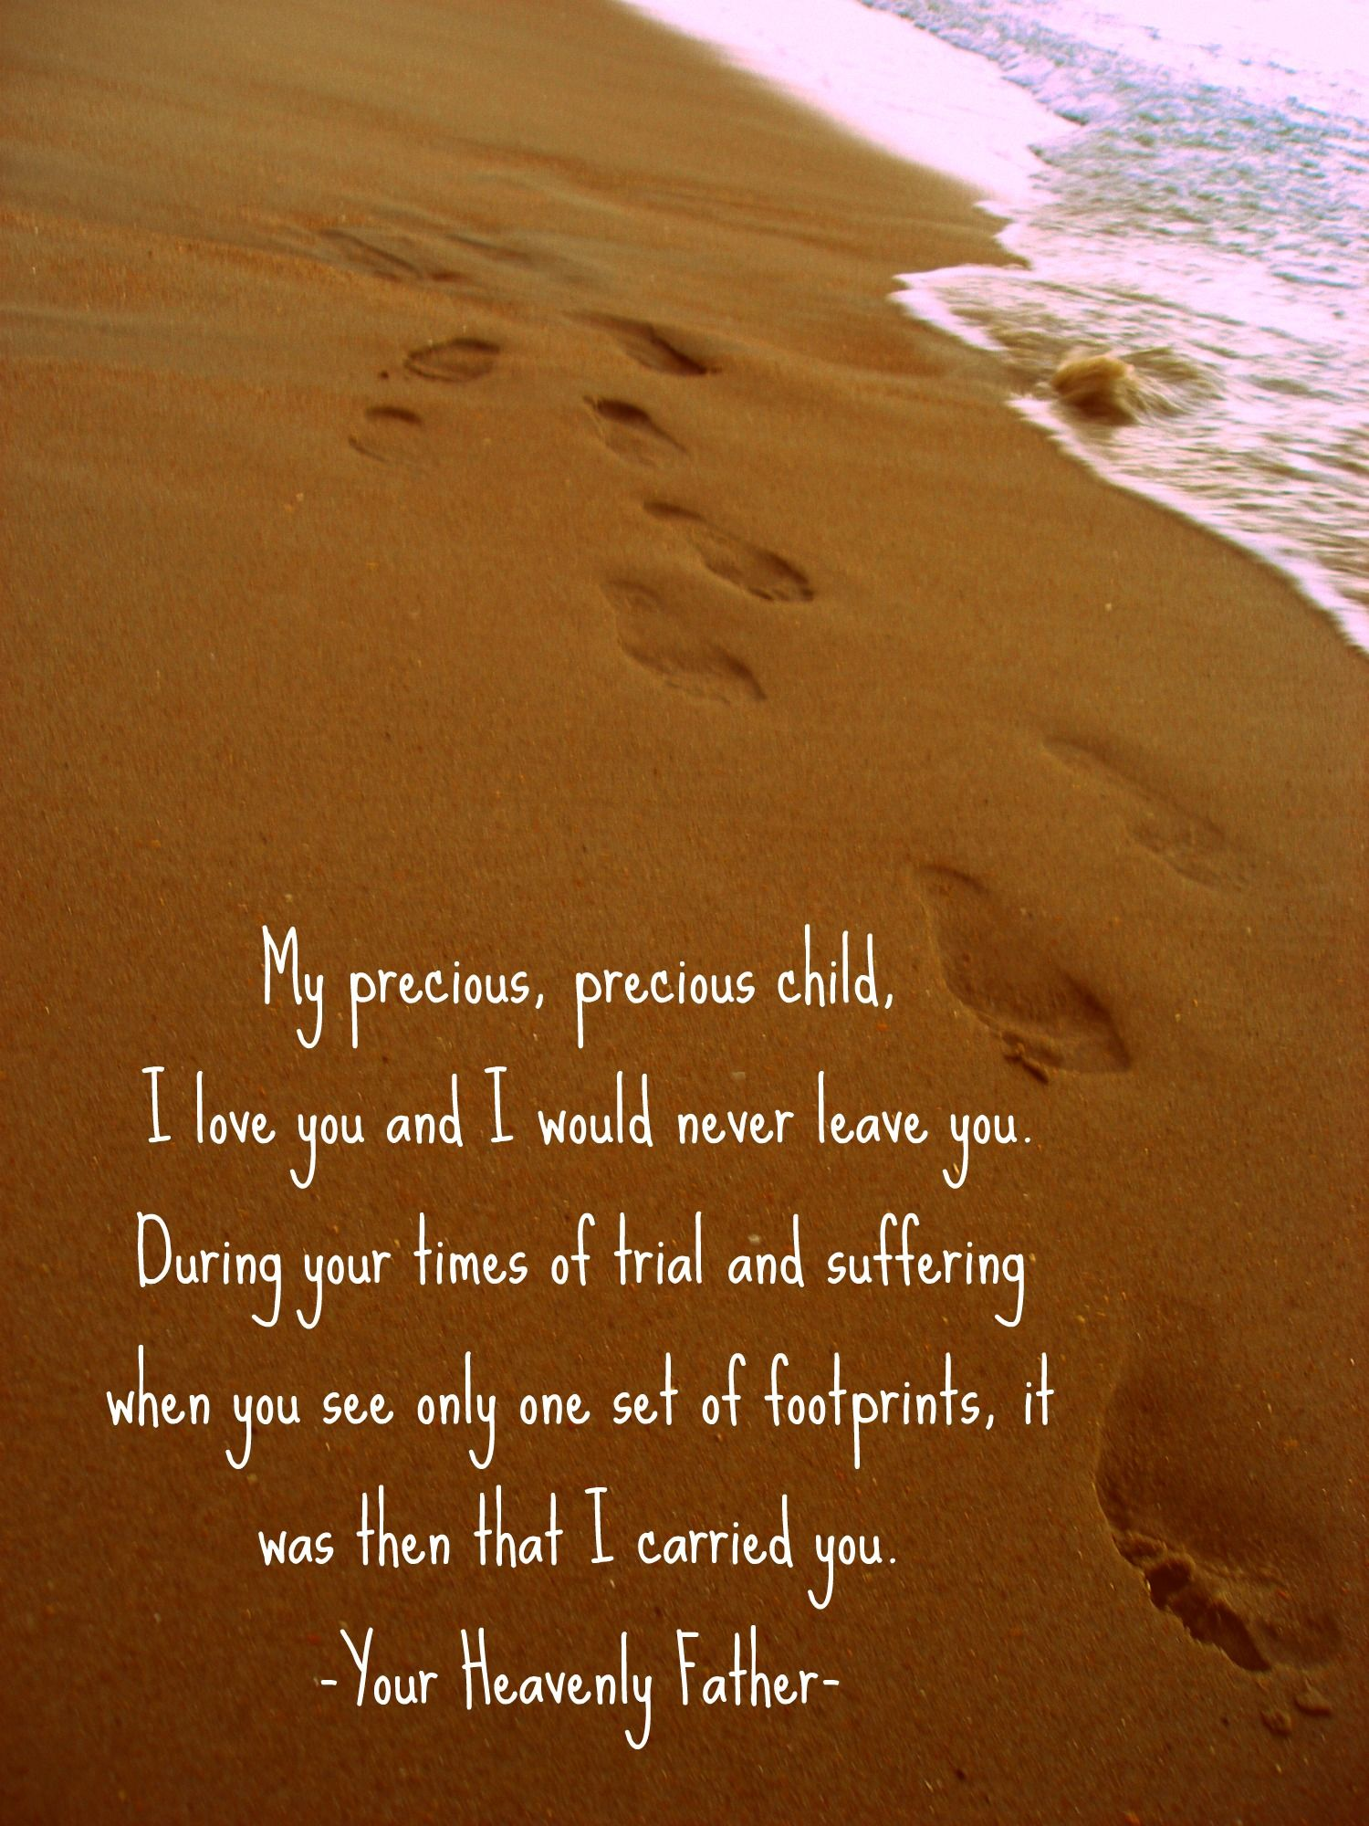

Book of Life

2019

Prayer of Blessing for Deceased Members 2021

Ever loving and gracious God.
We thank you for the gift you gave your church
In the women whose names are inscribed on these pages.

You called them
To be the salt of the earth
And a light to the world.

In their families and in their parish
They let their light shine before all
So that their good works
Gave glory to you
And were an example and encouragement for all of us.

As we hold close to our hearts
The memory of the women whose names are inscribed here,
We ask you to bless those members of
The Catholic Women’s League of Canada
Whom we honour on these pages.

We ask this blessing through Jesus Christ
And through the intercession of our patroness,
Our Lady of Good Counsel.
Amen

Prayer for the Book of Life
Adapted from The Catholic Women’s League Ceremonies Booklet, Page 1
Hamilton Diocesan Catholic Women’s League
List of Deceased Members for 2021

Brant Region

St. Basil, Brantford St. Pius X, Brantford
Gloria Isabel Novak Lucietta Cupoli
Silvana Petrella Kathryn Gillis
Carolyn Polilo Pauline Slosse
Lucienne Young Christina Terpstra

St. Joseph, Brantford Sacred Heart, Paris Adele Baran Joan Elliott
Lillian Moriarity
St. Mary, Brantford
Anna DiFelice
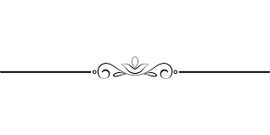
Betty Hurley
HAMILTON REGION

Holy Rosary, Burlington Canadian Martyrs, Hamilton
Carmela Damianco Joyce Zelinsky
Catherine Johns

St. John the Baptist, Burlington
Adela Rozenberg Cathedral Basilica of Christ the King,
Pauline Ustik Hamilton
Doris Wisniewski Anna Gatto
Vivienne McGrath
St. Raphael, Burlington
Claire Fedyko Regina Mundi, Hamilton
Joan Lawlor (2020) Luigina Spadafora
Shirley McBain
Aileen Smith (2020) St. Anthony of Padua, Hamilton
Rita Ann Calcagni
St. Augustine, Dundas
Mary Ann McNamara St. John the Baptist, Hamilton
Sharon Baillie Jessop
Holy Cross, Georgetown
Clare Ellis
St. Joseph, Hamilton St. Michael, Oakville
Bernadette Higgins Josephine Casha
Doris Knudsen Agnes Murphy
Louise Ormond
Sitenna Thomas Our Lady of the Assumption, Elfrida & Binbrook
St. Lawrence, Hamilton Rosina Bartolo
Elizabeth Smith Yolanda Burges
Joan Cowling
St. Luke, Hamilton Patricia Claire Neville
Marie Josephine Brennan Maria Sardo
Margaret Vera Schneider
St. Andrew, Oakville Ruth Kathryn Slattery
Anell Francis Lynne Smith
Bernice Rakoczy
St. Thomas the Apostle, Waterdown
St. Dominic, Oakville Eileen Sutton
Jacquelyne Lozier
Jeannine Sweeney Immaculate Heart of Mary, Winona Josephine Kozun
Eileen McIntrye-Roy

KITCHENER REGION

St. Joseph, Patron of Canada, Acton
Helen Klemencic
Basilica of Our Lady Immaculate,
St. John the Evangelist, Arthur Guelph
Eileen Schmidt Joyce Steffler
Rose Steinhoff
St. Clement, Cambridge
Ann Domjan Holy Rosary, Guelph
Shirley Downey Lucy Wojnarowski
Rita Kroker (2020)
Helen Renner (2020) Sacred Heart, Guelph
Mary Reddon
St. Joseph, Fergus
Mary Frances Lake
Blessed Sacrament, Kitchener St. Boniface, Maryhill
Reta May Lienhardt Elizabeth Frances Motz
Pateresa (Pat) Schiebel
Holy Family, New Hamburg
St. Anthony Daniel, Kitchener Judy Langford (2020)
Eileen Detzler Marie Egli
Inez Lloyd
Lorraine Nolan St. Agatha, St. Agatha
Anne Shantz (2020) Mary Eileen McClear
Bonnie Zajac
St. Agnes, Waterloo
St. Francis of Assisi, Kitchener Gwen Leslie
Donna Renaud Virginia Loos
Rita Lorbetski Loretta Schnarr
Carol Stortz
Edna Zinger St. Louis, Waterloo
Patricia Davies-Naim
St. Mary, Kitchener Helen Dietrich
Serena Eassy Carol Ann Dubeau
Patricia Claire Neville Eileen Fischer
Jacqui Parent Rosemary Peterson
Wilma Schill

NORTH REGION
St. Mary of the Assumption,
St. Ann, Chesley Owen Sound
Rita Vandervoort Kaye Keffer

St. Peter & St. Paul, Durham St. Joseph, Port Elgin
Marjorie Moyer Rita Gilbert
Kathy Yeo (2020)
Sacred Heart, Walkerton
Immaculate Conception, Formosa Grace Giesler (2020)
Sharon Rubick Rita Gilbert
Helen Weber

Sacred Heart, Mildmay
Verna Kay
Karen Seals
Diocesan Reports

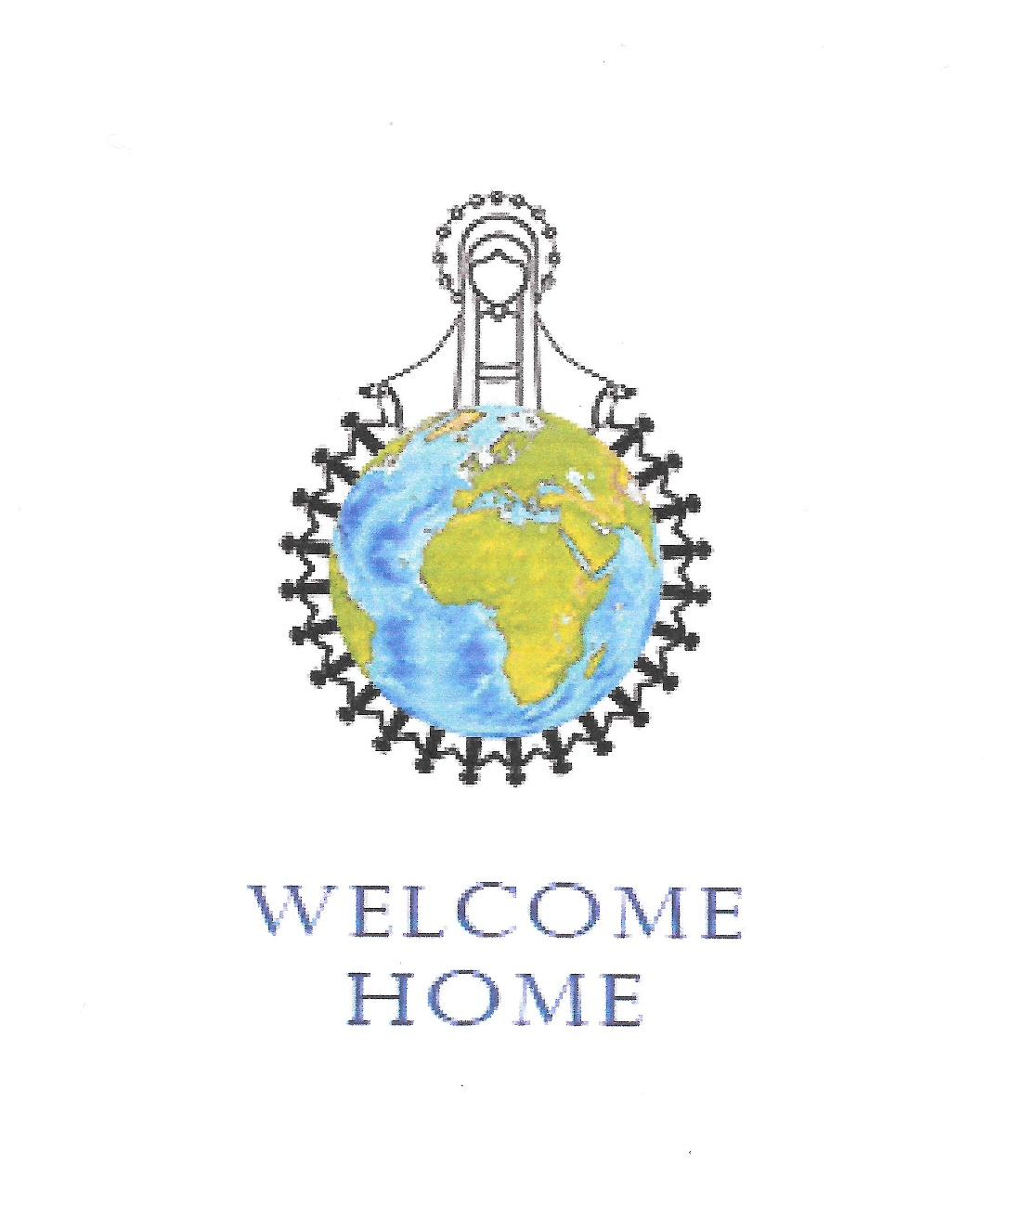

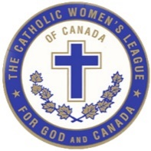
The Catholic Women’s League of Canada

Hamilton Diocesan Officers

Spiritual Advisor Father Larry Parent
President Catherine Feren
Joyce Cotter
Past President/Historian Joan Schurter
President-Elect Joyce Cotter/vacant
First Vice-President Teresa DiFalco
Secretary Laura Grint
Treasurer Julia Calverley

Committee Chairs

Spiritual Development Teresa DiFalco
Organization Joyce Cotter/vacant
Christian Family Life Christine McKenzie
Communications Mary Clark
Community Life Joanne Palmer
Education & Health Diane Jones
Resolutions Camille Naranjit/vacant
Legislation vacant

Regional Chairs

Brant/Hamilton Diana Quildon
Kathryn Imperatore
Kitchener/North Francesca Simone

Past President/Historian Annual Report 2021
Diocese: Hamilton Past President/Historian: Joan Schurter
Sub-chairpersons:
Parishes Reporting: 21/95 ____________________________________________________

Serve in a Consultative Capacity
- 30% of past presidents have been a CWL member for more than 25 years.
- 11% of past presidents are between the ages of 45-54, 42% between age 55-64 and 47% over the age of 75.
- Over half of past presidents have previously held this position.
- Over 85% of past presidents confirmed they almost always attend executive and general meetings, spiritual and social events.
- 45% of past presidents are called less than once a month for advice, but a strong 70% believe their current president felt supported and encouraged by their help.

Be Responsible for Archives and History
- 65% of past presidents were responsible for archives in their parish councils. A small number had a historian or an appointed member to assist.
- Over 85% stored their archives in a Catholic Women’s League room in their church with items in a cupboard, banker box or filing cabinet.
- Council archives were only reviewed as needed by over 80% of the respondents.
- 76% of past presidents knew the whereabouts of their council charter.
- Parish council historical archives included photo albums, scrapbooks, memory sticks, DVDs and CDs.
- The majority of the parish council’s annual reports, Books of Life, financial information, membership renewal dates, executive and general meeting minutes and records of pins and awards were kept indefinitely.
- Annual and written reports of executive members were stored by all but 10% of councils for a minimum of 1 – 4 years.
- 60% of the councils do not maintain a history book but maintain their labeled photo albums.

Study and Implementation of the Constitution and Bylaws
- 91% reported their parish council had a copy of the Constitution & Bylaws in their files, however, only 30% reviewed it on a yearly basis.
- 80% reported their parish councils had a copy of the National Manual of Policy and Procedure but less than 20% referred to the manual on a yearly basis to help with their own policy and procedures.
- Two thirds of the councils had their own parish council manual of policy and procedure and 50% reported it is updated when policies are changed.
- Of the parish councils reporting they do not have their own policy and procedure manual, 86% reported they would approach the diocesan level to assist them if they were going to develop one.
- Almost 50% of parish councils indicated they have rarely sought advice from the diocesan executive and that number increased for seeking advice from both provincial and national executive.
- Less than half of respondents sought advice from their spiritual advisor or area life members. Almost two thirds have rarely sought advice from their local bishop.

Other duties as Assigned by the President
- At the request of their president, past presidents have taken on numerous other duties:
  - 43% chaired the nomination and election committee,
  - 38% represented their councils at convention,
  - 33% promoted their council in their parish and community,
  - 29% chaired executive and general meetings,
  - 29% organized a social event,
  - 24% checked national and provincial websites for information to share,
  - 24% filled in the role of a vacant position or performed other duties
- To facilitate making their successor’s experience more enjoyable and fulfilling a past president role, respondents agree that communication is the key to success and supporting each other in their roles. Other recommendations include better succession planning, being more inclusive in the executive and find new participants to fill the key roles. Past presidents have offered to co-chair the first meeting of their successor’s term and planned the installation of the new executive officers together.

Communications
- Only 38% of parish councils are usually satisfied with the communication they receive from National council. Approximately 43% are satisfied with the communications received from Provincial, Diocesan and Regional Councils.
- Less than 40% of past presidents reported the communications received from National, Provincial and Diocesan councils was relevant.
- Approximately 30% reported the communications received from National, Provincial and Diocesan councils was clear and concise.
- 32% report receiving duplicate communications from National, Provincial, Diocesan and Regional councils.
- 32% parish councils supported the implementation of the envisioned future of the league through Planning Strategically 2018- 2020.

Successes of past presidents
- Stay connected with Zoom to hold executive/general meetings, & a weekly Rosary.
- Emails were sent to share information from National, Provincial and Diocesan.
- Executive members phoned other ‘sisters’ in the league to keep up to date.
- Funds were raised and items donated for a women’s shelter.
- Instituted, reviewed and added to their Policy and Procedure documents.
One hundred tulip bulbs were planted to celebrate our 100th anniversary.
- Held a parish fund-raising drive thru dinner.
- Organized a virtual World Day of Prayer.
- Formed a neighbourhood ecumenical social group.
- Support and presence shown for Catholic Education at First communion, Confirmation and Graduations.

Challenges of past presidents
- Lack of in-person meetings due to COVID and maintaining membership
- Explaining the need to increase fee because of the proposed fee increase by National was very difficult.
- Succession planning and finding people to fill the executive positions.
- Lack of leadership, communication, and cooperation from current president.
- Information sent from various levels rarely passed along to past president.
- Disconnect between levels. So much from National down is impossible to follow.
- Lack of advice on how to support a vibrant organization during COVID.
- Restrictions on virtual business meetings (can’t vote), so progress has been very limited.
- Disagreements with Pastor.

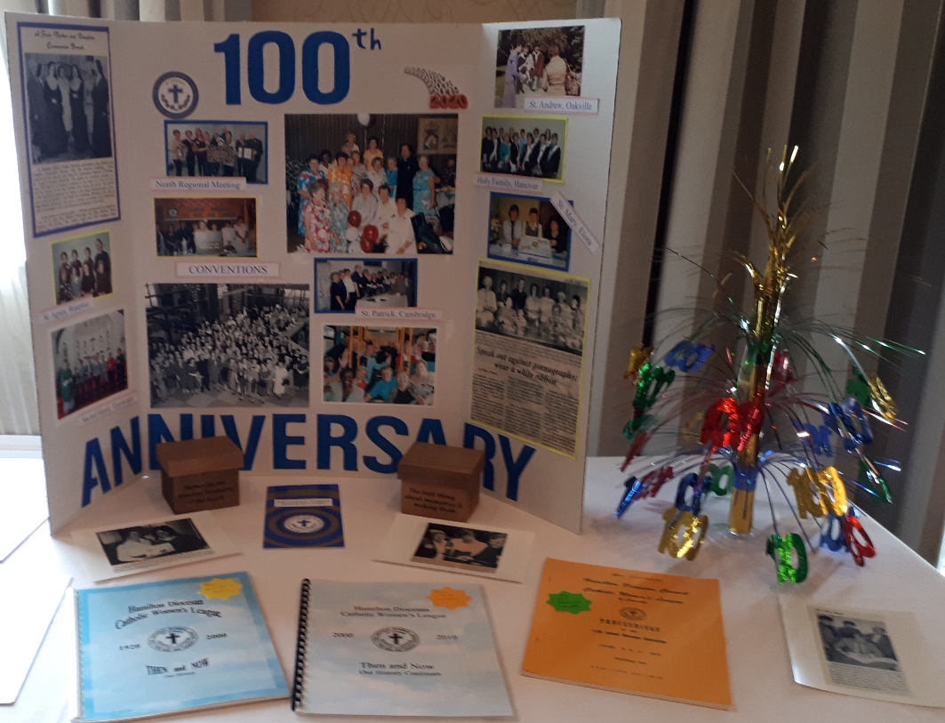

Recording Secretary’s Annual Report 2021
Diocese: Hamilton Secretary: Laura Grint
Sub-chairpersons: Kathryn Imperatore
Parishes Reporting: 28/95
__________________________________________________________________
28 of 95 Councils completed the Annual report survey. In these 28 councils 10 have both positions filled, 7 have an active recording secretary, 7 have one person doing both positions, 2 have a corresponding secretary, and 2 have neither. The following is a compilation in numbers and percentages of the answers given to the survey
Does your council have a Recording/Corresponding Secretary?
(36%) of the councils have both, (25%) have a recording secretary, (25%) have one person covering both positions, and (7%) has a corresponding secretary
Is the position of recording secretary vacant? – 12 (42%) reported position appointed and (54%) reported position elected 3 (4%) reported vacant

Take minutes at the meetings - 27 (90%) do and 1 (3%) don't

Is a signing officer – 17(68%) yes and 8 (32%) no

Know where the council charter is located - 17 (68%) Yes and 6 (24%) No
Maintain a list of the executive with their contact information -
26 (85%) do and 1 (4%) don't
Bring the motions books to all meetings 13 (46%l) do not have a motion book, 8 (29%) do bring the book, and 7 (25%) don’t know if there is one.
Receive written reports from the executive - 11 (39%) Yes, 13 (46%) Sometimes and 4 (14%) No

If your council does NOT have a recording secretary, who records the minutes at meetings – 3 (11%) reported someone else from the executive records the minutes such as Presidents or Past Presidents.

Is the position of corresponding secretary vacant in your council? - 2 (7%) reported position filled by one person 2 (9%) reported the position vacant and 7 (25%) reported one person holds both positions.

Does your council have a copy of the Handbook for Secretaries from National office?
16 (57%) reported yes and 1 (4%) reported no, 11(39%) did not know.

Does your council have a copy of the CWL Personal Letter Writing Guide from national office? 13 (46%) do and 3 (11%) no, and 12 (43%) don't know

Is there anything else you would like to share about your tasks as secretary? - 24 (86%) said no and 4 (14%) shared yes.
Many stated that the pandemic increased the hardship of bonding because they were not at meetings and that not all were tech savvy. It was hard for other to hear and they felt disconnected for a long time. They also stated they like the outreach cards and letters or phone calls from other members or the executive. Some stated they felt the communication was too much and as such wanted shorter more concise communications from levels above.

Great Job! Keep up the good work. It has been really stressful for us all and together we will get there. Bonded in the sisterhood with Mary.

Treasurer’s Standing Committee Report 2021
Diocese: Hamilton Chairperson: Julia Calverley/Mary Clark
Sub-chairpersons:
Parishes Reporting: 25/95

Thank you to the councils that submitted their report online. Even though it was another challenging year the report indicated total donations were made of $4000.00 to recognized organizations on National list; a total of $4230.00 to “other donations”. Councils expressed that they like to make donations to their local community rather than through the national volunteer fund. Good accounting practices are being followed, such as 2 signatures on cheques, budget preparation, monthly financial reporting at general meetings, and a small amount have their books examined annually.
The Diocesan Treasurer’s Annual Summary Report (attached) reflects the input of 32 parish councils. The total donations of $51089.00 indicates that you strived to continue your good works during a difficult time. Bravo!
Thank you for your generous donations received at the Saturday Eucharistic celebration at the 2019 Hamilton Diocesan Convention held in May. We were able to give $582.00 each to The Congregation of Sister’s of St. Joseph in Canada and Jesuit Forum.
The financial statements will be presented at the 102nd annual convention to be held on May 13 – 15 in Hamilton, Ontario. We have adopted the use of QuickBooks, so they will have a new look.
As we have not been able to hold an in person convention for the past two years, I will be presenting cheques to Bishop Crosby at the convention’s closing banquet for what has accumulated from 2019 to the end of 2021. Bishop’s Charities in the amount of $6,476.25, Development & Peace $222.00 and Our Lady of Good Counsel Seminary Bursary $2,167.93.
Thank you for all your great work you do for God and Canada!

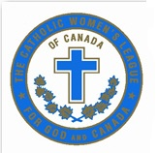
THE CATHOLIC WOMEN’S LEAGUE OF CANADA
ANNUAL PARISH TREASURER’S SUMMARY REPORT
FOR THE PERIOD JANUARY 1, 2021 TO DECEMBER 31, 2021
COUNCIL: HAMILTON DIOCESAN COUNCIL
LOCATION: HAMILTON, ONTARIO
COUNCIL PRESIDENT: JOYCE COTTER
TREASURER: MARY CLARK (Acting)

DONATIONS REPORTED BY 32/95 COUNCILS FOR PAST CALENDAR YEAR
National Voluntary Fund
Coady International Institute
Canadian Catholic Organization for Development and Peace |  | 435.00
Catholic Missions in Canada |  | 1750.00

Catholic Near East Welfare Association
Euthanasia Prevention Coalition (until August 18, 2020) |  | 100.00
National Bursary Fund |  | 300.00
National Voluntary Fund Sub-total |  | 2585.00
Standing Committees
Spiritual Development |  | 2169.00
Organization |  | 1008.00
Christian Family Life |  | 6839.00
Community Life |  | 14353.00
Education and Health |  | 8021.00
Communications |  | 749.00
Standing Committees Sub-total |  | 33139.00
All Donations
National Voluntary Fund Sub-total |  | 2585.00
Standing Committees Sub-total |  | 33139.00
Parish Donations |  | 15365.00
TOTAL |  | 51089.00

Financial Statement

For the period of January 1, 2021 to December 31, 2021

The financial contents of these pages have been deliberately omitted.

Spiritual Development Standing Committee Report 2021 Diocese: Hamilton Chairperson: Teresa DiFalco
Sub-chairpersons: Colleen Ionson, Maggie Lutz
Parishes Reporting: 21/95
__________________________________________________________________
Parish Councils reporting represents less than a ¼ of the Hamilton Diocesan Councils. 86% of the councils reported to have Spiritual Development Chair positions filled. 50% of these positions were filled via an election.
Spiritual Growth of Members
- 43% of councils spend one third of their meetings on spiritual development of members. COVID has played a big part in councils not being able to meet, or meeting briefly to address business only.
- 14% of Spiritual Development Chairs attended council meetings, despite 62% of councils having their spiritual advisor on their agendas. 52% report to praying daily rosaries.
- 38% use the national website for resources.
- 52% of councils participated in praying the rosary in May to end Covid. Covid offered a lot of time for members to pray more and to pray for others more.
- The Diocesan Spiritual Develop Chair offered many Spiritual Reflections and Retreats during the year, and many members attended. She also sends our great prayers and runs wonderful online programs. Members enhanced their spiritual programs through virtual means to gather and pray.

Study of Catholic Teachings
- 5% of councils study the bible. 24% of councils reported they encouraged members to discuss and study catholic teachings.
- 100% of councils have not studied Pope Francis’s encyclical Fratelli Tutti.

Role of Women in the Church
- 24% of councils reported they encouraged members to discuss and study the role of women in the church.

Evangelization and Mission Assistance
- 71% of parish councils have not reached out to women of other denominations or faiths.
- 5% of councils participated in the CWL Day of Prayer. Parish councils who assisted, supported CNEWA, Comboni Missionaries, Resurrectionists missions in Africa, Canada food for children, Salvation Army, sponsored a family in a developing country, supported Catholic Near East Welfare Association, Good Shepherd in Hamilton-Toronto, St. Vincent De Paul, De, Mazenod Door, provided 100 plus pneumonia vests, Catholic Missions, Catholic Help Line, Mental Health, Grey Bruce Health Care, and Shelter for Unwed Mothers.
Lay Ministries
- 52.5% of members participate in lay ministries.
- 19% of Spiritual Development Chairs participate in lay ministries.
- 34% of lay ministries are chaired/organized by a CWL member.
- 57% reported to participating as parish committee chairperson.
- 33% sit on the parish finance committee.
- 14% sit on the parish pastoral council.
- 67% reported that their parish does not have a liturgy committee, and for those that do, only 11% of members participate.

Ecumenism and Interfaith Endeavours
- 10% of parish councils reached out to other churches and other faiths and either invited them to social events or arranged a joint speaker.
- No parish councils participated in ecumenical activities, such as Fellowship of the Lease Coin, Week of Prayer for Christian Unity in January, or Women’s Inter-church Council of Canada.
- 62% of parish councils participated Word Day of Prayer in March. No parish councils participated in WUCWO Day in May.
- No parish council participate with Jewish, Muslim, Hindu, or Buddhist faith groups.
- 14% of parish council participated in activities with Indigenous interfaith groups.

In Summary and Other
The pandemic continues to be a challenge for councils, mostly because of the inability to meet. Despite this, I am pleased to report that councils have reacted positively to my emphasis on theological teachings of the Catholic faith, the role of women in the church and spiritual growth. This was done through virtual presentations, spiritual reflections, prayer services, retreats, and webinars. Councils also found the diocesan and provincial spiritual resource information helpful, as well as the provincial newsletter. Councils participated in League Development Day and attended the National Virtual Lenten Retreat.
Recommendations
The training initiative has caught on and councils are now reaching out asking for more. Other suggestions include: Sharing a pastoral calendar. Sharing information earlier. I defer to the recommendations I made in my 2020 report, with respect to ongoing training and webinars.
All in all, the pandemic has enabled our parish councils to fine innovative ways for spiritual development, connecting with members, and growing closer to their faith, one another and to God.

Organization Standing Committee Report 2021
Diocese: Hamilton Chairperson: Joyce Cotter
Sub-chairpersons: none
Parishes Reporting: 24/95
- 83% councils had a chairperson, 40% were elected, 60% appointed; 70% had positions previously
- Number of members who are: Oceana 3%, North American Indigenous 2%, European 28%, Latin, Central or South American 6%, Caribbean 3%, Other North American 46%, African 2%, Asian 4%, obvious minority 45%
- 75% councils agreed the CWL reflected the cultural diversity of the parish/community
- 5% councils have members under 35 years of age, 80% councils said it doesn’t reflect the age diversity of the parish/community
- Participation in fundraising: 50% had 1-20 members participate, 10% had 21-40 members participate, 30% had 41-60 members participate
- Participation in meetings: 65% had 1-20 members participate, 30% had 21-40 members participate, 5% had 41-60 members participate
- Participation in Social Events: 55% had 1-20 members participate, 15% had 21-40 members participate, 25% had 41-60 members participate, 5% had 61-80 members participate
- Participation in Spiritual Events: 60% had 1-20 members participate, 15% had 21-40 members participate, 20% had 41-60 members participate, 5% had 61-80 members participate

Recruit Members and Maintain Membership
- 6 councils had 2 new members, 5 councils had 0 new members, 4 councils had 1 new member, 3 councils had 5 new members, 2 councils had 3 new members and 2 councils had 6 new members, 1 council had 4 new members and 1 council had 18 new members**
- 6 councils had new members under the age of 40
- Recruitment methods most effective are: 63% personal invitation, 21% church bulletin/bulletin board, 8% presentation at masses, 4% pot luck dinners, membership teas, social events; 4% display tables at parish events
- Recognize members by: 74% cards or announcements, 65% presentation of service pins, 22% masses, phone calls, newsletter, congratulatory letter, 17% small gifts, 13% Maple Leaf service award, 13% presentation of awards, 9% reaffirmation ceremony, 4% luncheons, tea, special events, 4% new member ceremony, 4% presentation of certificates
- “Embracing Diversity: Tools for Council Use”: 8 councils had heard of this toolkit, 1 council downloaded from cwl.ca, 90% did not receive information from diocesan level, 2 councils used ads, 2 councils have planned multicultural celebrations
- Methods used to encourage cultural and age diversity are: 75% parish announcements, 63% bulletin boards, 56% ecumenism & interfaith endeavours, 50% personal invitations, 44% gift memberships, 31% parish schools/lay ministries, 31% council, parish, League website, 31% guest speaker, 6% social media, 6% cultural day celebrations
Leadership Development
- 6 councils had members in leadership roles in another level of the League: 5–diocesan, 4-regional, 1-provincial, 1-national
- 5 non-executive members took leadership roles in organizing events/projects
- 4 councils had positions filled by elections, 4 councils had positions fill be appointment, 3 councils had positions that were vacant

League Resource Material
- Welcome Program – 50% councils heard of this program, 3 councils downloaded program, 4 councils received from diocesan level, 2 councils implemented program
- 63% councils use online membership
- Executive Orientation Program – 33% councils heard of this program, 4 councils downloaded program, 5 councils received from diocesan level, 1 council had a workshop, 1 council presented to general members
- Strategic Planning Implementation – 7 councils knew of current activities
- 40% councils set annual goals/plans with members input

Annual Reports
- 8 councils made use of the guidelines to complete annual reports
- 10 councils didn’t feel survey demonstrated meaningful view of organization standing chair
- Councils felt survey questionnaire didn’t include effects of COVID on the parish council activities

Life Membership
- 4 councils gained assistance from Life Members

Chairperson’s Activities Report
- Attended and participated in executive meetings, in person and online
- Distributed information regarding annual reports to regional chairs, collected parish council annual reports and distributed them to the diocesan executive
- Prepared reports, Spectrum newsletter articles and directives, AMM meeting
- Compiled and edited the Annual Diocesan Report book for 2020
- In collaboration with communications chair, designed Hamilton highlights for OPC October newsletter
- Distributed information regarding Frances Lovering Award

Recommendations
- Organize workshops that include new information from strategic planning implementation
- Leadership training programs offered to parish councils
- Helping councils set up a newsletter either online or paper as great attraction to gaining new members and sharing information on League
- better communication of resources available to parish councils
- personal connection to members seems to be the draw for renewing membership
Christian Family Life Committee Report 2021
Diocese: Hamilton Chairperson: Christine McKenzie
Sub-chairpersons: none
Parishes Reporting: 16/95

Christian Family Life Chairpersons reported 50% of the positions were filled 13% elected and 88% appointed. Years of service: 50% -25 years, 13% - less than 5 years, 13% - 6-10 years, 13% - 11-15 years, 13% - 16-20 years, 50% - previously held this position. The age of members: 38% were age 75+, 31% - 65-74 years, 25% - 65-74 years, 6% - 45-54 years old
Marriage and Family
- There were no planned events to recognize Pope Francis Amoris Laetitia year as councils reported that 81% focused on other topics such as: Marriage Preparation courses and programs that supported married couples. Councils attended workshops on the topic of family life and supported people suffering from domestic abuse.
- Councils donated to Woman’s House of Bruce County, to local Food banks, Free Pantries, Christmas Angels, St, Vincent de Paul, Nova Vita Woman’s Shelter
- Marriage, Love and theology of the body through diocesan office
- Resources were provided through their website to Marriage and Family Part 1 and Part 2 “Catholic Moms” Ministry was supported in early initiatives
Sanctify of Life
- Councils reported 44% held membership in local pro-life organization
- Members attended: Pro-Life Masses, Pro Life Walks, 40 Days for Life, March for Life, Pro Life vigils and Life Chain,
- Monetary Donations/gifts: Local Pro Life Organizations, Birthright, Campaign Life Coalition, Euthanasia Prevention Coalition,
- Councils have copies of current pro-life brochures available in the Church
- Letters were written to inform legislators of CWL position on abortions and euthanasia.
- Councils prayed regularly for the protection of life
- The Federal Government was urged to provide legal protection to Children before birth
- Members wrote letters to the Prime Minister, Councils educated their members and recognized the day of prayer for legal protection of the child
- The Federal Government response to this resolution was monitored by 2 councils
- Councils protected the Sanctity of life by attending Life Chains, donating to local Pregnancy Centers, Right to Life, and Campaign Life Coalition
- Bill C-7 was supported by letter writing

Ministry to Youth
- The youth programs were promoted in the parish include: summer camps, World Youth Day, Sunday school, Catholic Christian Outreach and NET Ministries
- Scapulars were provided to first communion children and bibles were given to grade 4 children, youth awards at local schools
- Graduates from Elementary School and High School were given a gift of a Wooden Cross and a monetary donations
- Youth were encouraged to help with Christmas Bazaars for community hours
- Youths who wanted to participate in CCO Ministry were sponsored
Ministry to the Disabled
- Councils reached out to the disabled with: phone calls, cards of encouragement, Members brought communion, prayed with them, involved them in CWL events, provided transportation and imitated social programs.
- Councils supported organizations that reached out to the disabled by donations
Ministry to Widowed
- Widows and widowers were supported: by sending cards of condolence, prayers were offered after the death of a spouse
- Visits at home as well as phone call visits.
- Memorial services and funeral lunches were arranged
- Invitations were extended to attend community events, parish activities, as well as CWL meetings and events
Ministry to Separated and Divorced
- Members made phone calls to offer support

Ministry to Vocations
- Councils Supported Vocations: by praying for vocations, sending spiritual bouquets, adopting and supporting a seminarian.
- Hosting lunches for Priests and religious, inviting Priests and religious to speak on vocations
- Members viewed World Day of Prayer for vocations website for resources
- First Friday Masses held for vocations
- A traveling Crucifix goes from house to house monthly and all prayed for vocations

Recommendations
- Parish Councils could organize events to recognize and celebrate Pope Francis year of “Amoris Laetitia
- Councils should ensure every member has a copy of the current pro- life brochure from National office
- Encourage councils to meet with pro-life legislator
- Promotions within parishes to support World Youth Day 2023 should begin as soon as possible.
- Councils must be more involved with Separated and Divorced members of society. Members should be informed on the annulment process. Brochures Annulments Today Merciful and Just must be made available in the vestibule of the churches

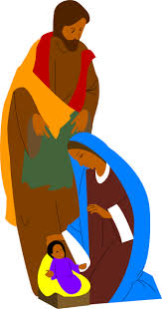

Communications Standing Committee Report 2021
Diocese: Hamilton Chairperson: Mary Clark
Sub-chairpersons: none
Parishes Reporting: 16/95
The Canadian League Magazine & National Website
The President's Message and articles relating to Pornography Hurts, Role of Women in the Church: A Personal Reflection, Action in the Time of COVID-19, Mandatory Age Verification: The Time to Act is Now, Make Valuable Use of This Time, Handy Hints, Highlights from the 100th and 101st National Annual Meetings of Members resonated 25% or higher with councils who read these articles in the 2021 Winter, Spring and Fall magazine.
I strongly urge councils to send in their milestones in The Canadian League Magazine. Let members across Canada see what is happening in your council!
14 councils encouraged members to use cwl.ca for current information. 8 councils encouraged members to visit Catholic Women's League on Facebook or Twitter. 14 Councils viewed the website and 6 councils are aware of the strategic plan
Visit all the websites for directives, prayers, forms etc. and to keep up to date on what is happening at all levels. National – cwl.ca; Provincial – cwl.on.ca; Diocesan – cwlhamilton.ca
Media: for Evangelization
10 councils promoted faith-oriented programs to members; 9 promoted National Day for Truth and Reconciliation while just 2 promoted World Communications Day (1st Sunday in June).
Councils showed their support (either financially or by subscription) to the following media to assist in their mission to evangelize: 3 -The Catholic Register; 3 -Mass for Shut-ins; 1 -Salt & Light TV; 1 –canadiandailymass.com; 1 - Vision TV, 0 for cccb.ca, EWTN and 1 for other. 10 councils showed no support.
Media: to Promote the League
Inviting members to share in with the League sponsored mass on April 26, 2020 in honour of the Feast of Our Lady of Good Counsel was done by 11 councils.
Councils that encouraged their members to use cwl.ca for current information was 14; 10 organized a phone committee to invite members to events; 2 made use of local media to advertise activities and events. Only 1 council set aside a budget for publicity.
The top five types of media used to promote council activities and events were email 15 including meeting agenda and minutes; church bulletins 12; church bulletin boards 9; bulletin inserts 9; telephone committees 8; along with the use of their parish website, Facebook, school newsletters, local newspapers, and community webpages.
Media: Evaluation and Promotion of Good Content
Of the 16 councils that reported 8 councils were not sure and 8 reported no to having encouraged their members to monitor media content. There were no councils or members who spoke out about inappropriate content.
Media: Newsletter and Bulletins
The production of a newsletter was done by 9 councils this past year. They were done by either or both the Communications Chair and President. Seven newsletters were distributed through email, 3 mail and 2 in the parish bulletin.
Media: Relations
While 12 councils did not reach out to their local media, 2 invited them to events, 1 submitted publication material and 1 advertised with them.
Pornography
To be kept informed about the influence of pornography members of 4 councils read newspaper articles; 1 reviewed current legislation, 0 attended a seminar or conference; 0 viewed the website fightthenewdrug.org; and 0 did other while 9 councils haven't taken any action.
In 2021, 15 councils did not distribute Pornography Hurts postcards. 1 Council sent out postcards in November.
Promotion of the documentary Over 18 was done by 2 councils and 2 councils promoted the Red Light Green Light film with 1 holding information sessions.
Up to 4 councils have made their members aware and acted on Resolution 2017.02, Resolution 2004.11 and Resolution 2002.11.
Strategic Planning
Six councils shared with their members the strategic planning information. Members are reminded that monthly updates can be found on the national website.
Due to the ongoing pandemic, many councils were restricted as to what they were able to do. Some councils continued to reach out to the members by phone calls, emailing or mailing newsletters, and sending greeting cards for Birthdays, Easter, Christmas, Get Well, and Sympathy.
I encourage the women of The Catholic Women's League of Canada to continue doing GOOD WORKS through God and Canada!

Community Life Standing Committee Report 2021
Diocese: Hamilton Chairperson: Joanne Palmer
Sub-chairpersons: none
Parishes Reporting: 10/95
This position is 60% filled and 40% vacant, with 50% elected, 50% appointed. Six councils have not held this position previously. Sixty percent of chairperson were a member for 25 years, 20 % were members for under 5 years, and 10 % were members for 6-15 years.

Dignity and Rights of Person
- Does the Parish Council members know what the Universal Declaration
Of Human Rights are? 60% yes, 40% no.
- Councils supported minority groups :with guest speakers, workshops, donations or volunteered:
    - Those incarcerated - No.
    - Those suffering from bulling - No.
    - Those suffering from domestic violence - No
    - Those suffering from homelessness - No.
    - Those suffering from human trafficking - No.
    - Those suffering from poverty - donations 60%, volunteered 40%, guest speaker 0%, workshop 0%.
    - Those suffering from racism - No
- Have you as a chairperson been aware of:
  - The struggles of Indigenous women - Yes 6%, No 33%.
  - Bill C-262 United Nations Declaration on the rights of Indigenous people - No
  - Human Trafficking - yes 67%, no 33%. Did not share information.
  - Council took part in Day of Prayer for Human Trafficking -10% yes.

Social and Economic Justice
- Councils supported social and economic justice: 90% yes, financial support 50%, and prayerful support 50%.
- Councils supported these organizations:
  - Anti-poverty - volunteer 100%.
  - After school programs - financial 100%, volunteer 100%.
  - Clothing drives - volunteer 67%, financial 33%.
  - Drop-in Centres - volunteer 50%, financial 100%.
  - Emergency shelter for victims of domestic abuse - Financial 100%.
  - Food Banks - financial 83%, prayerful 33%, volunteer 33%.
  - Food Hampers – Financial 75%, prayerful 50%, volunteer 50%.
  - Soup Kitchen - volunteer 75%, financial 50%, and prayerful 25%.
- Councils support and assist Indigenous people: 30% yes.
- A council supported the Social Justice group in our parish
- Councils recognized the first National Day for Truth and Reconciliation - 50% yes, 50% no.
- Offered prayers, attended mass, shared links to prayer sites, the Bishop’s letter, attended candlelight service.
- Did you wear orange in September for the Residential School - 70% no, 30% yes

Refugees, Immigration and Citizenship
- Information about the Immigration and Refugee policies - 83% no, 17% yes.
- How would you rate your members about the needs of immigration and refugees:
  - Availability of employment: 40% good, 30% fair, 20% poor, 10% excellent.
  - English language classes: 83% fair, 17% poor.
  - Financial assistance for food and rent: 50% fair, 33% poor, 17% good.
  - Countries of origin of immigration and refugees: 50% fair, 33% poor, 17% good.
  - Numbers of immigrants and refugees in the community: 67% fair, 33% poor.
- Councils knew the difference between temporary foreign workers, Immigrant and refugee: 60% yes, 40% no.
- 80 % councils took part in Remembrance Day services.
- 90% councils took part in the poppy campaign
- 50% councils wore red to support the Canadian Troops
- Have you continued to monitor Resolution 2016.01 Equal Access to Permanent Resident Status: 90% no, 10% yes.

Canadian Catholic Organization for Development & Peace (CCODP)
- Do council members know what CCODP do: 70% no, 30% yes.
- Did the council take part in the 1% program: 90% no, 10% yes.

Developing Countries
- Councils that were aware of the child and labour in developing countries 50% no, 30% somewhat, 20% yes
- Councils that criticized structures that put profit before people: 50% no, 33% yes, 17% somewhat
- Organizations supported: Chalice 50%, Canadian Red Cross 50%, Habitat for Humanity 25%, Operation Christmas Child 25%.

Success Stories
- Members have been participating in special prayers for CWL members, CWL seminars and prayers presented by the Diocesan Council.
- Council promoted Red Day in August for kids returning to school in September
- Plant & garage sale in fall where monetary donations & food donations were given to Salvation Army Wiarton food bank
- A craft night to get members together brought out 10 women whereas the previous meeting we had 5
- Clothing collected, canned and packaged goods donated to local food bank

Education and Health Standing Committee Report 2021
Diocese: Hamilton Chairperson: Diane Jones
Sub-chairpersons: none
Parishes Reporting: 12/95
- 75% had this position filled on the parish council, 25% filled by appointment
- 64% have been a member for 25 years, 18% have been a member for 11-15 years 9% have been a member for 6-10 years, 9% have been a member for less than 5 years, 18% have been a member for 11-15 years, 50% held this position previously
- 17% members were in the age bracket 75–84, 42% members were in the age bracket 65-74, 25% members were in the age bracket 56-64, 8% members were in the age bracket 45–54, 8% members were in the age bracket 35–44, none under the age of 18
Catholic Schools and Catechesis
- 67% have become informed about the quality of Catholic religious instruction in the parish and have inquired how to support the programs
- 67% have become informed about the quality of Catholic religious instruction in the Catholic schools in the area/diocese
- 56% actively encouraged parental participation in all areas of their children’s Catholic school education and activities
- 50% asked local schools about their needs that could be met by the council:
- 67% for scholarships needs, bursaries, 50% for sacramental/faith development
- 33% for school supplies, 17% for extracurricular and other graduation needs

Rites of Christian Initiation
- 25% were involved in Rites of Christian Initiation programs by assisting or with communications with those going through the process, or as facilitators. As there are few candidates, priests are doing the work themselves.

Literacy and Continuing Education
- 22% encouraged members to assist with literacy learning skills
- 25% councils have a current list of Catholic universities or colleges
- 33% councils have a list of scholarships and bursaries that are available and could be accessed by Catholic women to further their education

Scholarships and Bursaries
- 58% councils provide a bursary or scholarship
- 8% provided a bursary, 8% provided a scholarship to elementary students
- 33% provided a bursary, 25% provide a scholarship to high school students
- No councils provided a scholarship to university/college students
- 8% gave to NET, no council has ordered the revised bursary certificate from National office for downloading.
- 8% promoted the National Bursary Fund utilizing the newly developed brochure.
- Other included donating a bible as a Christian Humanitarian Award to a young lady in the graduating classes of each of their elementary feeder schools. Some provided an award to grade 8 students based on an application process and a bursary and certificate, to a grade 12 student based on their application process.
- No members made application, contributed to the National Bursary Fund nor promoted to their council that members could include a legacy in their will to support the National Bursary Fund.
- 8% contributed to Coady International Institute this year.

Wellness and Sickness/Disease
- 67% not aware of the CWL Mental Health Postcard campaign, no one participated
- 67% did not support areas of the national organizations that focus on the health and wellness of Canadians, 17% participated in other areas. Areas supported were 8% each to Alzheimer Society of Canada, Canadian Cancer Society, Heart & Stroke Foundation, Catholic Health Alliance of Canada, Mater Care International, and Ronald McDonald House Charities Canada. Other donations were kept in the community: to Women’s Crisis Centre Community Support connections, local hospitals, Pornography Hurts Campaign, Catholic Missions In Canada, Fruits of Bruce/Canadian Food Grains, Grey/Bruce Mentorship, Right-to-Life, Canadian Food for Children, local hospice, Hanover and Ramoth, Mount Forest pregnancy centres, Women’s House in Kincardine, Chalice Sponsor a Child, Wes for Youth, Fotocan, elementary school donations for first communion/confirmation, and for gifts/masses for shut-ins and seniors. 67% used the Palliative Care postcard
- No council supported the Canadian Blood Services.
- 17% provided info on advance care planning, 8% on emergency response kits
- 33% councils participated in the Care for Our Common Home initiative

Environment
- 17% planted a tree to commemorate the 100th anniversary of the League
- 25% did plastic and waste cleanup at home, church, mostly on individual basis
- Environmental issues addressed were: recycling 25%, reduce the use of Styrofoam 25%, other topics 42%, with 8% on each of the followings: eliminate plastic water bottles, plastic straws, green bins for organic waste, reduce water, compost, and roadside or community clean-up 17%. 17% celebrated the United Nations World Water Day on March 22, 2021. No council participated in Earth Day.

Genetics
- Knowledge in regard to the advantages and disadvantages of technology to alter genes in light of the teaching of the Catholic Church was rated as: poor 56%, very good 22%, good 11%, and fair 11%. No councils received the Canadian Catholic Bioethics Institute newsletter.

Resolutions Standing Committee Report 2021
Diocese: Hamilton Chairperson: Camille L. Naranjit/vacant
Sub-chairpersons:
Parishes Reporting: 6/95

Research and Preparation of Resolutions and Briefs
- 2/6 councils have chairpersons for Resolutions Standing Committee, with one appointed and one elected
- Executive members participated in the snap survey
- No contact with local government officials by councils
- Contact with provincial representative:1 council sent emails, 1 council sent letters, 1 council called by phone, no councils met in person
- Contact with federal representative: 1 council sent emails, 1 council sent letters

Study and Implementation of Resolutions Passed by Other Levels
- 1 council participated in virtual resolutions workshop
- No resolutions were presented in 2021 by parish councils
- 1 council referred to communiques from higher levels of the League to learn what the resolutions were, learn more about each resolution
- councils studied “Euthanasia & Assisted Dying, COVID safety & vaccines
- 1 council signed petitions, another council wrote letters concerning housing for the homeless

Chairperson’s Activities Report
- Wrote tip sheet and misconceptions on resolution writing for spring newsletter
- Gave councils “Prayer for Resolutions Chairpersons”
- Prepared report for the 2020 Annual Diocesan Report book
- Prepared report for the provincial Resolutions chairperson
- Used Executive Handbook as a resource, informed councils of newly revised 2020 Resolutions Handbook
- Attended and participated in executive meetings, in person and online

Recommendations
- Look at the CWL action plan under each current resolution and pick a specific resolution for all councils in Hamilton diocese to work on together
- Invite local MPP or MP to guest speak at a general meeting, discuss resolution CWL action plans with them
- Have round table discussions on current news, have newspapers to perk interest in a resolution
- Challenges – no chairperson, no interest in resolutions, smaller councils = need to perk their interest, promote advocacy
- Promote leadership training for resolutions

Legislation Standing Committee Report 2021
Diocese: Hamilton Chairperson: Vacant
Sub-chairpersons:
Parishes Reporting: 10/95

Monitor and Study Legislation at All Levels of Government
- 4 councils have legislation chairpersons, two were elected, two were appointed
- 2 councils receive mailings from municipal, provincial and federal government representatives
- No councils attended public forums sponsored by the government
- 2 chairpersons are well informed on current local government issues while 2 chairpersons were somewhat informed on the issues
- Provincial and Federal government issues: 3 chairpersons were somewhat informed, while 1 chairperson was very informed
- Resources used were: 50% Hansard records of federal government proceedings, 50% federal department of justice website, 25% LEGISinfo

Council awareness of current issues:

- Bill C-7 Criminal Code Medical Assistance in Dying (MAID) – 50% were very aware, 50% some knowledge
- Bill C-233 Criminal Code Sex-Selective Abortion – 50% had some knowledge, 30% had no awareness, 20% were very aware
- Bill C-268 Criminal Code Intimidation of Health Care Professionals – 60% had some knowledge, 30% were very aware, 10% no awareness

Council monitored/acted on Federal Bills:

- Bill C-3 Criminal Code The Canada Labour Code
- Bill C-6 Criminal Code Conversion Therapy
- Bill S-203 Criminal Code Ending the Captivity of Whales and Dolphins
- Bill C-8 Amend the Citizenship Act (Truth and Reconciliation Commission of Canada’s call to action 94

Council monitored/acted on Provincial Bills
- Bill 14 2020:Municipal Affairs and Housing Statues Amendment Act

Preparation of Briefs and Position Papers on Proposed Legislation
- Councils did not used “Faith in Action” legislation workshop from National
- 5 councils were not aware of workshop, 2 councils didn’t receive the information, 2 councils showed lack of interest

Chairperson’s Activities Report
- Resolutions Chairperson Camille Naranjit prepared a report for the Annual Diocesan Report book
- Resolutions Chairperson Camille Naranjit prepared a report for the provincial Legislation Chairperson

Recommendations
- Promote leadership training for legislation
- Follow through on resolutions being acted on in legislation
- Have a month set aside for “connecting with government” – send letters, email, etc.
- Highlight Bills to watch in newsletter
- Survey councils to see if information is not being received by upper levels or not being shared amongst the council chairpersons, or not being shared amongst the members
- Relate Government Bills to local community/area
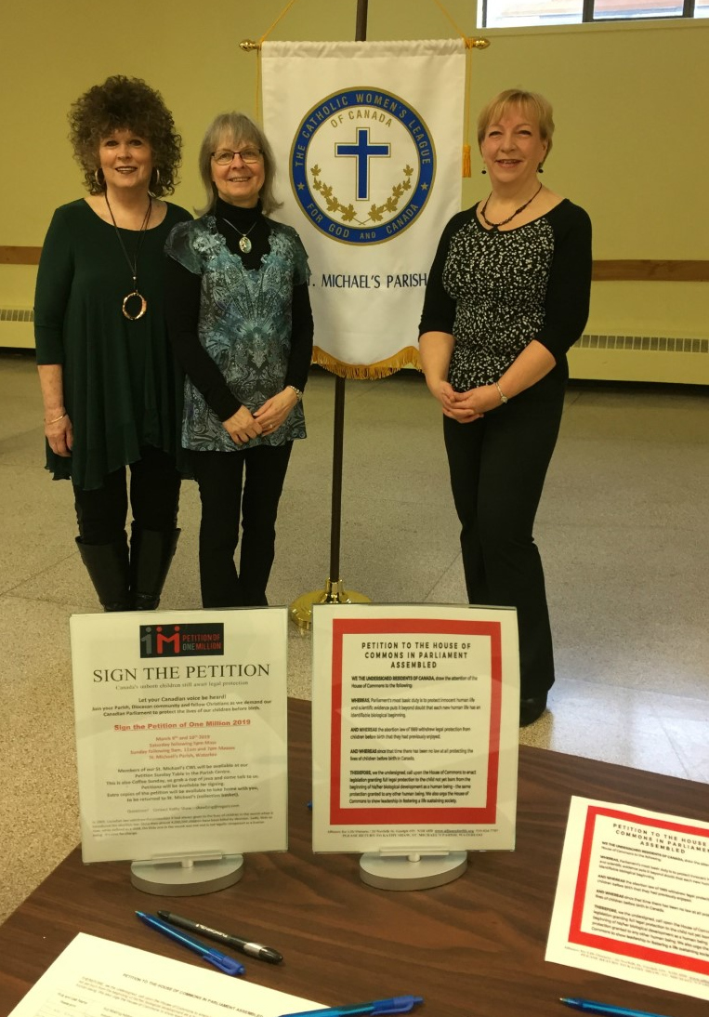

Life Member Liaison Report 2021
Diocese: Hamilton Life Member Liaison: Rosanne Sogan
Honorary Life Members: none
Life Members: 10

Life Member Liaison’s Activity Report

This past year, with COVID-19 still looming over us, activities in the parishes and with the Life Members were quieter than normal.

Anna Brady: Anna and her husband, Phil, are both recovering from health issues which crept up on them, with both spending some time in hospital. Anna has returned to attending Mass in person since some COVID-19 restrictions were lifted. She continued to be active in her parish, counting money bi-weekly. She also continued to be active in her PROBUS (a retiree teachers social group), and RWTO (Retired Women Teacher’s Organization) group which met several times between shutdowns. Anna continued her work as convention co-chair for the diocesan convention. She attended the Zoom meetings for Regional, Diocesan, Provincial and National annual meetings.

Mary Lou Colwell: Mary Lou feels remiss about not being an active Life Member as she had not attended any council meetings for some time. Mary welcomed a new grandchild last year. She and her husband, Alan, are doing well.

Pat Crawford: Pat continued to work throughout COVID-19 in the neighborhood store where she has worked for many years. Her own CWL council continued to struggle, like many others in the diocese, province, and across the country. She felt more cut off because of an old computer which is not compatible for Zoom meetings.

Shari Guinta: Shari continued as parish council secretary. Shari and her husband Peter, blessed with 2 children were busy during the summer celebrating both children’s weddings within several weeks of one another. She continued on the board of directors for the Brothers of the Good Shepherd and on her League journey by sitting on the national council. She has helped to mentor those in her parish council and others throughout the diocese. She attended the Zoom meetings for Regional, Diocesan, Provincial and National annual meetings.

Jakki Jeffs: Jakki, her husband Paul, and family are doing well. Jakki found this past year to be very difficult for everyone as people became more afraid of everything. She has prayed more than ever for leaders, not only those in governments. The COVID-19 lockdowns created effects on parish councils and fracturing society. Jakki noted that previous generations endured difficult times and the League became stronger for it.
Jacqui Papke: Jacqui and her husband Lloyd have stayed as well as can be. Jacqui’s commitment to, and continued support of those in the League remains important to her.

Rosanne Sogan: Rosanne continued working throughout the pandemic as an elementary school secretary. Rosanne underwent total hip surgery in October but it did not stop her from work, League business or family life. As council secretary, she continued doing minutes of executive meetings and updated council records. She continued being a Eucharistic Minister and Minister of the Word at Masses following lockdowns. Rosanne, as Diocesan Life Member Liaison, forwarded the diocesan Life Members all material received from, diocesan, provincial and national councils as directed. She sent cards of sympathy, birthday wishes, Christmas cards and card of greetings to many members. She attended the Zoom meetings for Regional, Diocesan, Provincial meetings. A gathering had been planned for an annual Life Members Christmas lunch however COVID-19 protocol denied the group of the gathering. Rosanne, her husband Bruce and family have stayed healthy throughout this past year and await the birth of their fourth grandchild.

Ana Sousa: Ana continued working in the medical field during the COVID-19 battle. Ana remained very involved in her parish as greeter, usher, Minister of the Word, Eucharistic Minister, cleaning and money counter. She continued to support her council president and sister members during the few meetings held. Ana continued her work on diocesan convention as convention co-chair. She attended the Zoom meetings for Regional, Diocesan, Provincial and National annual meetings.

Mary Lou Watson: Mary Lou stayed well during this past year spending most of her time minding her grandchildren after school and while her daughter worked and took courses. Mary found that the winter was very snowy and unusually cold and shoveling snow became exhausting. Her council had not been able to meet during the pandemic other than for elections.

Jeanne Wilson: Jeanne attended Mass when the church was open, otherwise she watched it online. Jeanne worked on and delivered the CWL Grade 8 awards for her council. She attended the Zoom meetings for Regional, Diocesan, Provincial and National meetings. Her council has been meeting when possible for planning meeting and general meeting. Attendance was low but she is hopeful for it to increase.

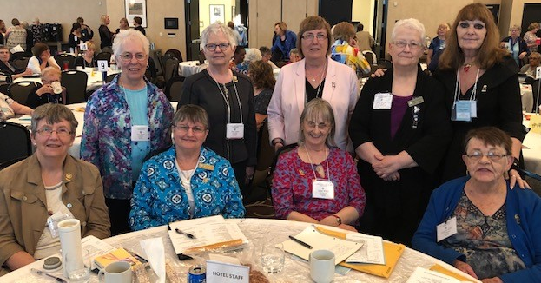

Regional Reports

CWL COUNCILS IN HAMILTON DIOCESE

BRANT REGION HAMILTON CONT’D
St. Eugene
BRANTFORD St. Gregory the Great
St. Basil St. John the Baptist
St. Joseph St. Joseph
St. Mary St. Lawrence
St. Pius X St. Luke
BURFORD St. Margaret Mary
Blessed Sacrament St. Patrick
PARIS St. Stanislaus
Sacred Heart MILTON
SCOTLAND Holy Rosary
St. Anthony St. Benedict
OAKVILLE
HAMILTON REGION Mary Mother of God
St. Andrew
BURLINGTON St. Dominic
Holy Rosary St. James
St. Gabriel St. Matthew
St. John the Baptist St. Michael
St. Patrick STONEY CREEK
St. Paul the Apostle Our Lady of the Assumption
St. Raphael St. Francis Xavier
DUNDAS WATERDOWN
St. Augustine St. Thomas the Apostle
FREELTON WINONA
Our Lady of Mount Carmel Immaculate Heart of Mary
GEORGETOWN
Holy Cross
HAMILTON
Annunciation of Our Lord
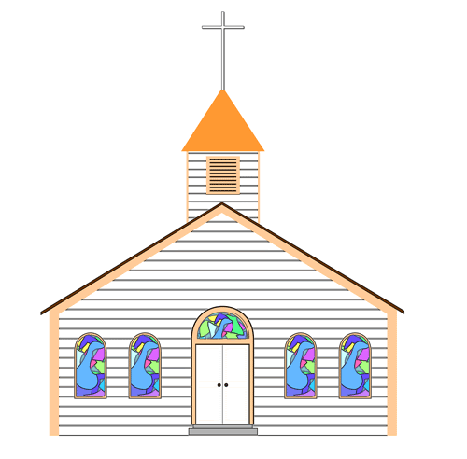
Most Blessed Sacrament
Canadian Martyrs
Cathedral Basilica of Christ the King
Corpus Christi
Regina Mundi
Sacred Heart
St. Anthony of Padua
St. Catherine of Siena
St. Charles Garnier

KITCHENER REGION ROCKWOOD AND OUSTIC
Sacred Heart & St. Peter Mission
ACTON St. AGATHA
St. Joseph, Patron of Canada St. Agatha
ARTHUR WATERLOO
St. John the Evangelist Our Lady of Lourdes
CAMBRIDGE St. Agnes
St. Clement St. Louis
St. Gregory the Great St. Michael
St. Mary of the Visitation
St. Patrick NORTH REGION
DRAYTON
St. Martin of Tours CARGILL
ELMIRA St. Joseph
St. Teresa of Avila CHEPSTOW
ELORA Mary Immaculate
St. Mary Immaculate CHESLEY
FERGUS St. Ann
St. Joseph DUNDALK
GUELPH Our Lady of the Rosary
Basilica of Our Lady Immaculate DURHAM
Holy Rosary St. Peter and St. Paul
Sacred Heart FORMOSA
St. John Immaculate Conception
St. Joseph GLENELG
KENILWORTH St. John
Sacred Heart HANOVER
KITCHENER Holy Family
Blessed Sacrament KINCARDINE
St. Aloysius St. Anthony of Padua
St. Anthony Daniel MILDMAY
St. Francis of Assisi Sacred Heart
St. John MOUNT FOREST
St. Joseph St. Mary of the Purification
St. Mark OWEN SOUND
St. Mary St. Mary of the Assumption
St. Teresa of Avila PORT ELGIN
MARYHILL St. Joseph
St. Boniface TEESWATER
NEW HAMBURG Sacred Heart
Holy Family WALKERTON
Sacred Heart
WIARTON
St. Thomas Aquinas
___________________________________________________________________________ Name of Council: St. Pius X, Brantford
Hamilton Diocesan Council
Of
The Catholic Women’s League of Canada
Care for Our Common Home
Name of President: Patricia McDougall
Spiritual Advisor: N/A
Number of members: 108 Life Members: 0
Greetings from the St. Pius X Parish Catholic Women’s League. As the Covid pandemic was still a strongly felt concern, we were not often able to meet in person. Through our phone tree members, we stayed in touch with the ladies as best we could; through calling, mailed newsletters and cards, and through the zoom program.
It was with deep sadness that our valued Spiritual Advisor, Father John
Redmond, went to join the Lord in August 2021. Eleven of our members remembered his life with a candle-lit honour guard during a Celebration of Life Mass. It was very well attended.
Ten more members were added to our Book of Life this year. May they now
rest in the Light of the Lord. A Mass for our members Living and Deceased was held in December.
We had a successful donation drive for the Warmth and Comfort program, collecting about 375 items; these were distributed to people in need in the community. We are contributing also, to the Food Bank Project.
Our student awards for both elementary and secondary schools were well
received by the deserving students.
Several ladies joined the October ‘Chat in the Hat’ AMM on zoom. It was fun, informative and great to see many familiar faces.
We were able to hold lively discussions concerning the Instructed Vote with our members. It is an important part of our National Constitution and By-laws.
In November, we assembled Christmas gift packages for our Seniors in the community. They were safely delivered following Covid protocols. I am pleased to report that one of our members will be turning 100 years old coming this July. We will honour her with a small social gathering.
Many of our ladies volunteer in supporting Parish programs like The Search, and meals for the priests during reconciliation evenings, with their time and baking. Let 2022 be a year of regrowth, renewed faith and increased strength in our sisterhood. Mary lived a life pleasing to God. May we do God’s will in all things, “Mary, Mother of God, pray for us.”
___________________________________________________________________________
Hamilton Diocesan Council
Of
The Catholic Women’s League of Canada
Care for Our Common Home
Name of Council: St Paul the Apostle, Burlington
Name of Co-Presidents: Susan Williams and Shelley Monaco
Spiritual Advisor: Father John Schnurr
Number of members: 124 Life members: 0
While the news kept reminding us of a pandemic we tried to continue moving forward and lifting spirits within our council. Susan Williams continued to send her well-crafted CWL newsletters that turned into a weekly ministry many looked forward to and a much-needed link to our council and parish. Through this newsletter word spread of prayer requests, births, deaths, faithful and inspirational illustrations, poems of encouragement and much more. It especially served those who weren’t comfortable leaving their homes or attending mass.
In March we organized a Drive-thru Food Drive in our church parking lot. This simple event proved successful in many ways. Several members and parishioners we hadn’t seen in months, drove in and visited from their cars while the sun shone and gave us all hope. This community event collected over 2,000 pounds of food for the Burlington West Food Bank.
During the month of May, we zoomed the Rosary with our members and Spiritual Advisor. It was wonderful to see everyone again.
We repeated the Drive-thru Food Drive again in the fall on a cold rainy weekend and were delighted to gather as much food and donations for the local Salvation Army foodbank. They were overjoyed at our offerings.
Our Annual Christmas Bazaar was altered for the second time into a well-orchestrated online auction as our way of saying ‘the show must go on’! It proved successful in raising over $6,000.00 to benefit our local community and chosen charities.
We continue to support our members to the best of our ability while recognizing needs with mass and prayer cards for our members, as well as monthly Baptism cards for our parish families. Our faithfulness and creativity throughout this past year has sustained our membership and we look ahead to many more opportunities but most
of all gathering again.
May God continue to bless us all.

_______________________________________________________________________
Hamilton Diocesan Council
Of
The Catholic Women’s League of Canada
Care for Our Common Home
Name of Council: Our Lady of Mount Carmel, Freelton
Name of President: Judy Van Schyndel
Spiritual Advisor: Father Edward Mahony
Number of members: 35 Life Members: 0

Dear Sisters in the League,
Throughout the second year of the Covid-19 pandemic, 2021, we continued to serve and stay in touch with our members in the following ways.
- continued with our CWL Zoom Rosary recitation on Wednesday evenings
- continued our monthly Executive meetings by Zoom
- At Easter, we sent out prayer cards and an Easter letter to each of our members
- In June, we presented Bibles to the grade 8 award winners at Our Lady of Mount Carmel School
- continued to collect and deliver donations to the Men’s Street Ministry in Hamilton throughout the year
- celebrated Father Mahony’s 45th Anniversary of Ordination with a gift presentation at mass
- held an Advent Retreat with Father Mahony
- purchased 4 copies of the Catholic Register’s Commemorative Magazine about the Catholic Women’s League of Canada, celebrating the 100th Anniversary of the League, and presented them to members and placed one in the Church Library
- held a very successful Christmas Outdoor Planter fundraiser in November
- Throughout the year, two of our members quilted 94 Mug Mats which we sold in December at another successful fundraiser
- Christmas cards were mailed to every member with a “Catholic and Living It” prayer card included in each one.
We continue to pray together, hope together and serve together in Faith. We wish God’s blessings of peace, safety, good health and joy to all of our sisters in the League. Respectfully submitted.
______________________________________________________________________________
Hamilton Diocesan Council
Of
The Catholic Women’s League of Canada
Care for Our Common Home
Name of Council: Regina Mundi, Hamilton
Name of President: Dolores Morrallee
Spiritual Advisor: Father Adam Voisin
Number of Members: 100 Life Members: 0

This again has been a year of uncertainty with lock downs, physical distancing, and limitations on gatherings, but through it all this Council has persevered. We have kept as closely as we were able to the mission of the Catholic Women’s League. We have continued our support to the many charities that we have supported for over sixty years. Without being able to do full fundraisers we have had to use our limited monetary resources to continue that support. In the fall we were able to have a small fundraiser which helped significantly allowing us to carry on.

While the church was open, we were able to offer our Liturgy of the Blessed Virgin Mary and a beautiful Crowning after Mass. This was a well-attended spiritual evening held in October.

As restrictions ease up and more parishioners return to the church, we will be able to get back to more normality and continue offering the many spiritual days, retreats, and many other events we had done in the past.

As always, Regina Mundi Council is grateful to Father Adam Voisin, our Spiritual Advisor and Deacon Randy Matters for their continued support and a special thankyou to all our executive members who have given so much to keep our council working.

___________________________________________________________________________
Hamilton Diocesan Council
Of
The Catholic Women’s League of Canada
Care for Our Common Home
Name of Council: St. Patrick, Hamilton
Name of President: Evelyn Shoemaker
Spiritual Advisor: Diana Quildon
Number of members: 28 paid still working on 11
Life Members: 0

Pandemic years have been tough on our council as I’m sure many other councils. Zoom meetings don’t go over very well as most of our members are not technically literate and don’t have equipment. Fundraising is next to impossible with the parish open, closed, partly open and we never know what is going to be the status. I am happy to say that we have been busily knitting and crocheting prayer shawls with 30 beautiful shawls being blessed at mass last spring.
We started working on the Milk Bag Sleeping Mat project in the fall of 2020 and the project has been a tremendous success. Parishioners bring in their milk bags, we have monthly workshops to cut the bags into strips and create plarn then weave or crochet the mats. To date we have created over 20 mats and donated them to Hamilton’s Social Navigator team for distribution to the homeless population. St Catherine of Sienna parish attended one of our workshops and has taken the project back to their parish with much success there as well.
At Christmas 2021 our council baked 30 dozen cookies for distribution at the Social Navigator Team’s winter coat giveaway.
Our council is starting to get back on track, we held elections and presented 40 year pins to 3 members at our meeting in March; hosted Mary’s Way of the cross during lent and have another meeting in April.
We also embarked on another interesting project, surveying our members asking which ministries they are involved in the parish. 19 out of 40 members responded that they are involved in 54 ministries within the parish. That is a huge contribution to the parish and an eye-opening exercise.

______________________________________________________________________________
Hamilton Diocesan Council
Of
The Catholic Women’s League of Canada
Care for Our Common Home
Name of Council: St. Andrew, Oakville
Name of President: Yvette Vukanovich
Spiritual Advisor: Father Cornelius O’Mahony
Number of members: 82 Life Members: 0

St. Andrew has been busy with the following in 2021:
January, 2021
Executive Meeting via Zoom
February 2021
Members emailed Senate to intervene on behalf of Palliative Care Bill C-7
Members emailed prayers & litany for World Day of Sick/Feast of our Lady of Lourdes – also watched Mass online
Members took part in Virtual CWL Ottawa Diocesan League Development Day
Supported Deacon Richard & Family as they walked for the homeless (Coldest Night of the Year)
Newsletter and Bill C-7 update sent to members
Funeral for Bernice Rakoczky (Long Time Member)
March 2021
Members encouraged to watch livestreamed masses
Members attended National CWL virtual Lenten Retreat
Members attended livestream Retreat for Holy Week
April 2021
Easter Message sent to Members
Executive Meeting – planning of our 100th Anniversary (2022)
Members encouraged to pray for front-line workers when attending livestreamed masses
Prayer to our Lady of Good Counsel sent to members & they are encouraged to watch Vision TV mass
May 2021
Members encouraged to watch CWL National Webinar on Palliative Care
Mother’s Day wishes sent to members
Prayers for the repose of the soul of Anell Francis
Feast of Our Lady of Fatima – members encouraged to watch Mass for Life on Salt and Light TV
Feast of the Visitation – members watched via Zoom the film on Mary presented by Dr. Josephine Lombardi
June 2021
Prayers said for Pat Murphy (Our Executive Member Terry’s Murphy’s Mom)
Prayers for the repose of the soul of member Cecilia Palmer
July 2021
Mass (livestreamed) & special prayers for St. Joseph
Socially Distanced First Friday Coffee on Parish Centre Deck
Hosted Tuesday Open House following noon mass
Congratulations send to Father Felix on his 42 years of ordination
Catered a Clergy Appreciation Dinner for Fr. Con, Fr. Felix, Deacon Richard & his wife, Marie
Members attended vigil for Pat Murphy (60 year member)
Attended Funeral with Honour Guard for Pat Murphy
August 2021
3 Executive Planning Meetings for our 100th Anniversary
CWL hosted Sacramental Coordinator & Lynette Brown’s farewell luncheon
September 2021
Newsletter sent to members
Coffee on deck following noon mass
General Meeting held outdoors on Parish Deck
Attended Regional (Hat Chat) meeting via zoom
Members encouraged to participate in National Day of Faith Zoom Meeting
Members participated in the Adoration of the Blessed Sacrament following Wednesday’s mass
Mass for National Day for Truth & Reconciliation followed by coffee
October 2021
Packaged & sold tulip, daffodil & hyacinth bulbs for our 100th Anniversary fundraiser
Members asked to pray of Sanctity of Life and members emailed regarding Right to Life Sunday & activities of Halton Alive
Tulip panting at church (100 bulbs for 100th Anniversary)
Zoom Meeting – CWL Annual Day of Faith
AGM 2020, 2021 Zoom attended by members
November 2021
All Saints Mass (in lieu of meeting)
Funeral for Michael Craggs (son & brother of members)
Members made snowflakes for seniors in LTC for Halton Alive
December 2021
Members assisted in Parish/Advent “Brown Bag” Outreach Program
Organized registration & seating for masses
Attended (live or virtually) discussion on the Synod with FR. Con & Fr. Joseph de Viveiros
Funeral mass for Veronica Murphy (Executive Member’s Aunt)
Presented Clergy Christmas gifts
_____________________________________________________________________________

Hamilton Diocesan Council
Of
The Catholic Women’s League of Canada

Care for Our Common Home
Name of Council: St. Matthew, Oakville
Name of President: Jeanne Wilson
Spiritual Advisor: Father Allen Varlaki
Number of members: 35 Life Members: 1

St. Matthew’s Catholic Women’s has tried to keep active.
In June, we gave grade 8 awards to 6 elementary schools.
In August, I attended the virtual National meeting.
Our council did not meet in person until August when we held a planning meeting.
In September, we had a presentation on Rose Prince. I attended the virtual regional meeting.
In October, I attended the virtual AGM. We had a presentation by Terry and Joanne Murphy who gave a beautiful presentation on their work with indigenous people in various parishes in Northern Saskatchewan. Pornography Hurt postcards were given out. The vote on National fees was held.
In November we had an informative presentation by Dwayne Cahill, manager of Cemeteries of the Diocese of Hamilton, on A Guide to Planning a Catholic Funeral.
In December, our spiritual advisor, Fr. Allan, gave a spiritual on advent and Our Lady of Guadalupe. We held our instructed vote on changes to the National C&B.
We tried to hold elections, but have not been successful. Many of our members are reluctant to attend in person meetings. We are currently operating without a president, secretary and treasurer. At our last meeting, in April, we had 8 members including a new member which was very encouraging.

_______________________________________________________________________
Hamilton Diocesan Council
Of
The Catholic Women’s League of Canada
Care for Our Common Home
Name of Council: St. Francis Xavier, Stoney Creek
Name of President: Louise Castellani
Spiritual Advisor: Father Ross Campbell
Number of members: 119 Life Members: 0

Twenty twenty-0ne was an interesting year. Even though we were unable to meet in person regularly several of the members of St Francis CWL Council were very busy. The amazing and thorough newsletters sent out monthly by Angie Garside made it so much easier to recount what happened. She also participated in the Life Chain.

On Mother’s Day Flowers were placed in front of the Statue of Mary by our members as usual and our members led the Stations of the Cross one Friday in Lent.

In June Bibles were delivered to 4 of our 5 feeder schools & service pins were delivered to those with 25, 40, 50, & 60 years of service.

A Spiritual Bouquet and a parting gift were presented to Father Mariusz to thank him for his dedication and service to our parish.

Fifteen of our members attended the retreat at Mount Carmel. It was organised & facilitated by our Spiritual Development Chair, Carol Pin, who helped us “Find God in our Everyday Lives.”

Rose D’Agostino went well beyond the call of duty sending out sympathy cards, thinking of you cards, Mass cards, thank you cards and 23 Christmas cards to shut ins & nursing home members.

We are very grateful for the support of our executive especially Francesca Simone who kept members in the loop by forwarding messages and newsletters and to Mary Harmon and Carol Pin who were looking after membership and to Adele Granata who kept us posted about bank statements and made sure our Chalice child received payment.

I thank all those who donated to and/or helped pack approximately 20 Purses and 15 backpacks for the ladies and children at Martha house. We hope our donation made their Christmas a little merrier.

_______________________________________________________________________
Hamilton Diocesan Council
Of
The Catholic Women’s League of Canada
Care for Our Common Home
Hamilton Diocesan Council
Of
The Catholic Women’s League of Canada
Care for Our Common Home
Name of Council: Immaculate Heart of Mary, Winona
Name of President: Adele van Troost
Spiritual Advisor: Father William Trusz
Number of members: 96 Life Members: 0

This past year, like the one before, was subdued because of Covid and the many restrictions. We were able to do some activities within the Covid restrictions.

We led the annual Lenten Stations of the Cross. We made paper flowers for Easter and paper snowflakes for Christmas for Halton Alive, who distributed them to the Retirement Homes and Long Term Care Facilities in our area.

We kept in touch with our members by sending out Easter and Christmas cards along with newsletters.

Members and friends of our league continued to knit Prayer Shawls for those who are not well and need comfort. We had our presentation of service pins and blessing of our prayer shawls after our Christmas mass.

Also, at this presentation we awarded Maple Leaf pins to two of our long time members who have contributed their time to the executive, council activities and their talent by making, for many years, mittens and hats to those in need in our community.

_______________________________________________________________________
Hamilton Diocesan Council
Of
The Catholic Women’s League of Canada
Care for Our Common Home
Hamilton Diocesan Council
Of
The Catholic Women’s League of Canada
Care for Our Common Home
Name of Council: St. Joseph, Patron of Canada, Acton
Name of President: Christie deSouza
Spiritual Advisor: Father Mark Sullivan
Number of members: 60 Life Members: 0
January 2021
– began streaming the rosary before 11:30 Mass stream every week
February 2021
– Lent: Eddie hosted weekly Lenten retreat on Zoom using “The Search” on Formed
– provided home-made cherry cheesecakes for Knights' Friday Lenten Fish Fry orders – raised $500 through whole of Lent
March 2021
– began Confirmation classes for grade 7s on Zoom (weekly on Sundays and repeated on Tuesdays) and continued for 7 weeks leading up to Confirmation in May
June 2021
- Student awards ($50, $50, $100) to worthy local elementary and high school girls
- cookie-baking for July 1st gifting to group homes
July 2021
- home-made cookie tray for each of the local group homes to celebrate Canada Day
September 2021
- pie making for Thanksgiving fundraising
October 2021
- made $380 from the pies
- diaper drive for Michael House
November 2021
- CWL Christmas Dinner (and sort-of meeting) at Tanner's
- discussion and voting on CWL National Constitution and Bylaw amendments 1, 3, & 4 regarding wording and streamlining of officers and duties
December 2021
- cookie baking and sale for fundraising – made $415
- poinsettias and Mass cards for shut-ins and those in need in the parish
_______________________________________________________________________
Hamilton Diocesan Council
Of
The Catholic Women’s League of Canada
Care for Our Common Home
Hamilton Diocesan Council
Of
The Catholic Women’s League of Canada
Care for Our Common Home
Name of Council: St. Joseph, Fergus
Name of President: Judy Daniel
Spiritual Advisor: Father Ken Miskiewicz
Number of members: 64 Life Members: 0

With another year struggling with the pandemic, we were able to hold one in-person meeting on November 6th for a Special Mass followed by the informed voting required by National.

We acknowledged a milestone birthday of one of our members, who turned 102 on May 3rd, by presenting her with a Spiritual Bouquet.

We presented 37 First Holy Communion gifts and 48 Confirmation gifts.

We mailed/delivered 11 Christmas Cards to our homebound and shut-ins.

We presented our Parish Staff (4) with Christmas Gifts in the form of a cheque.

Our current CWL Executive met virtually 6 times throughout the year addressing issues of urgency on behalf of our membership. All actions taken will be presented to the membership when we are able to meet in-person for their ratification.

I attended 4 regional chats virtually throughout the year.

____________________________________________________________________________
Hamilton Diocesan Council
Of
The Catholic Women’s League of Canada

Care for Our Common Home
Name of Council: St. Joseph, Guelph
Name of President: Wendy Synnott
Spiritual Advisor: Father Jeff Bergsma
Number of members: 167 Life Members: 0

St. Joseph’s CWL. Guelph is a very active Parish. We begin each
Meeting with Mass and followed by our regular meeting.

Due to the Covid-19. We did not conduct any meetings, But did the
Following.

We delivered service pins to those who qualified in the past two years.

We honoured our High School Graduates at two schools with a cheque and a plaque this year.

We have returned to our general meetings. With the co-operation of the
Knights have taken on the project of giving the kitchen a thorough cleaning.

Three funerals were served one of which was a long time member.

_________________________________________________________________________
Hamilton Diocesan Council
Of
The Catholic Women’s League of Canada
Care for Our Common Home
Name of Council: Blessed Sacrament, Kitchener
Name of President: Judy Knight
Spiritual Advisor: Father Pawel Stankiewicz
Number of members: Life Members: 0

I really do not have that much to say since our last report.

In March we had a Lenten retreat done by Father Pawel, it was his first time doing this & he did a great job. After the retreat we had the vote for the Constitution & By-laws. About 30 showed up.

We decided that we were going to have the crowning of Mary in May as well as the mass for our deceased members at the same time.

With the covid these last few years it has put a damper on any activities or fund raisers for the CWL. Our dues have been sent in, & hopefully there will be enough money for our convention.

The Knights of Columbus have approached me to have a spaghetti dinner at our parish & all funds would be given back to us. We will be having elections soon & hoping someone will come forward to fill the executive positions.

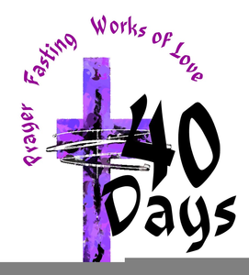

_______________________________________________________________________
Hamilton Diocesan Council
Of
The Catholic Women’s League of Canada
Care for Our Common Home
Name of Council: St. Anthony Daniel, Kitchener
Name of President: Theresa Miller
Spiritual Advisor: Father Vivek Trindade
Number of members: 116 Life Members: 0
As we continued staying home for most of this past year, our council tried to keep in touch with our members by emails and phone calls.
We started a Prayer Group which prayed for the intentions of our members, whether they were sick, had family members having operations, were seeking employment, or were lonely and needed our prayers. This was organized by our Spiritual Development Chair, Joan Schurter.
We were able to gather in church for a morning mass the first Thursday of each month to pray for the intentions of our living and deceased members. We usually had around 20 members who were able to attend these masses.
We gave out bursaries to three grade eight students this year to help with costs for secondary school. And we were able to award the First Communion and Confirmation children with a small memento of their sacraments.
We managed to hold the Instructed votes from National and these were sent to the appropriate councils.
We forwarded all of the information from the Diocesan, Provincial and National Councils to our members who have email, and called the others. Our members were happy to participate in the reflections, Chats, and informational ZOOMS.
We are fortunate to have Father Vivek fill in for us for a year. At one of our gatherings, we heard all about his life and how he chose to become a priest.
We are praying for a return to in person meetings soon, but continue to pray to Our Lady of Counsel for guidance.

_______________________________________________________________________
Hamilton Diocesan Council
Of
The Catholic Women’s League of Canada
Care for Our Common Home
Name of Council: St. John, Kitchener
Name of President: Wende Bedirian
Spiritual Advisor: Father Francisco Cruz
Number of Members: 46 Life Members: 0

Regretfully, due to the pandemic, we were unable to have any meetings during 2021. Members kept in touch through emails and telephone calls. Three members celebrated their 40 year milestone, Shirley Gosselin, Olga Perko and Carol Wesseling. Two of our members were deceased in 2021.
Blessed rosaries and pocket crosses were presented to 26 children at the First Holy Communion Masses on October 20 and October 21, 2021.

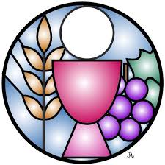

___________________________________________________________________________
Hamilton Diocesan Council
Of
The Catholic Women’s League of Canada

Care for Our Common Home
Name of Council: St. Teresa, Kitchener
Name of President: Mary Alice Zister
Spiritual Advisor: Father Marian Gil
Number of members: 100 Life Members: 1

Thanks to a dedicated executive we have had several very successful executive meetings on Zoom. These meetings were fast, efficient, and friendly. It was a joy to ‘see’ our friends and get caught up. We did attempt a general meeting on Zoom but were disappointed since only the executive attended.
We could not have our annual Craft and Bake Sale so we opted for a successful online Silent Auction. It was fun and addictive for some of us and we learned a few things for our next fundraising auction!
At Christmas time we had a very successful personal item drive for Canadian Food for Children. This included hand soap, shampoo, tooth paste and tooth brushes. An executive member organized and had two young ladies from the parish help.
Beginning in of 2020 a member of the executive has mailed Easter cards, Thinking of You cards, Valentines, and Christmas Cards to senior members, those in nursing homes, and shut-ins.
Several of us have kept in touch with our senior and not so senior ladies with phone calls and ‘driveway visits’. It was handy to keep a couple of folding chairs in the trunks of our cars!
Our visiting committee met in November 2021 to organize visits to our shut-ins, etc. We were soon closed down by restrictions. An effort was made to contact the people on our lists.
There have been some bumps in the road but our members have been very willing to help overcome challenges.
We pray the Rosary before funeral Masses and have an honour guard for members who have passed away but participation is dropping. A number of our faithful ladies have died or gone to retirement/nursing homes. We are considering what our next step should be.

_______________________________________________________________________
Hamilton Diocesan Council
Of
The Catholic Women’s League of Canada
Care for Our Common Home
Name of Council: St. Agatha, St. Agatha
Name of President: Theresa Bisch
Spiritual Advisor: Currently we don’t have one
Number of members: 76 Life Members: 0

2021 was another challenging year due to the pandemic. Our executive met virtually, although our monthly general meetings had to be cancelled for the early part of the year. From September to December we were able to have those meetings in the parish hall, with COVID restrictions in place.

Our CWL stayed in touch with members and offered support, by sending out newsletters to members via email and we continue to maintain a Facebook page. We sent flowers to our members who celebrated 90th birthdays and perpetual prayer cards for 80th. We phoned people who were sick and housebound, since we were not able to visit them in person. We continued to provide socially distanced honour guards for our members who earned their eternal reward in Heaven.

Even though spring was under strict lockdowns, we still organized a garden tour for early summer. The event was a huge success and brought the entire parish together for fellowship and fun in a safe environment. We had a hotdog stand that also served Pop Shop soda at one location (where the children got to try their hand at opening the bottles with an old-fashioned bottle opener), a raffle at another and butter tart sales at another stop. There was a little game of “spot the gnome” at each garden and everyone enjoyed searching for them in their hiding places. The gardens were unique, beautiful and creative. One had an indoor/outdoor aquarium while another had a “surprise” garden hidden behind a normal residential house. There were sunny gardens, farm gardens and rock gardens. No matter where they were located, all had unique features. It was obvious to everyone who attended, just how much love and work went into creating these treasured spaces. This event was an important break from the isolation we all felt during the pandemic. It was a chance to stop and literally smell the roses for a day, while visiting with our fellow parishioners and neighbours. The smiles on everyone’s faces said it all!

The pandemic has been difficult but has also challenged all of us to find creative ways to maintain community within our parish. We were blessed to be able to enhance our parish life throughout 2021.

_________________________________________________________________________
Hamilton Diocesan Council
Of
The Catholic Women’s League of Canada
Care for Our Common Home
Name of Council: St. Agnes, Waterloo
Name of President: Julie Nafziger
Spiritual Advisor: Father Aleks Mazur
Number of members: 136 Life Members: 0

Hello sisters:

Like all of you, we were forced to cancel all of our events and celebrations for 2021.
My biggest challenge was finding a way to stay connected with our members. So I put a quilt up and started to call members for a chat while I was quilting. For those with email, I sent biweekly “thinking of you” messages. These were not necessarily of a spiritual nature, but just expressing concern and caring, sometimes a joke and always with the invitation to call me anytime. I included my home phone number and a surprising number of members did give me a quick call to let me know they were ok and appreciated the contact.

For those members without email, I started to write notes and letters and cards. It was an enormous undertaking, but one that was very much appreciated by all who received a card or a note. I sent extra cards to those members who are homebound either in their own home or in a retirement or long term care home as those were very lonely days.

We look forward to a more normal spring and summer when we can meet without fear (or masks).

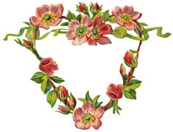

_________________________________________________________________________
Hamilton Diocesan Council
Of
The Catholic Women’s League of Canada
Care for Our Common Home
Name of Council: St. Louis, Waterloo
Name of President: Donna Herbstreit
Spiritual Advisor: Father Phil Reilly
Number of members: 110 Life Members: 0

Our first meeting of 2021 was held on October 6th. As is well known, meeting earlier than this was not possible due to the pandemic. On this day, we had a ceremony, held outside, by our centennial tree that we planted in May of 2020. It was a beautiful fall evening! We had a plaque made stating the significance of the tree. We honoured one of our deceased members, Carol Dubeau who donated all of the funds needed to pay for the tree and the plaque. This was followed by Mass. Father allowed us to stay in the Church for our meeting, masked and distanced. The members enjoyed a 30 minute performance by a country/gospel band headed by a member of our parish. We had 36 members attend and you could see the joy in their eyes to once again be together. No one wanted to leave!

November 3rd was the date of our second meeting, once again following Mass and once again remaining in the Church with Father’s blessing. One of our long time members, Sandy Williams, heads the Prayer Shawl Ministry. She brought many of the beautiful knitted and crocheted shawls for us to see, Father to bless, take if we needed one. She informed us that since 2007, 2600 prayer shawls were given away. I was so grateful to be gifted one that evening.

On the weekend of November 20th and 21st, we held a Bake and Raffle Sale in the gym. All COVID protocols were followed. Many parishioners were involved to make this a happy and successful event. The total proceeds amounted to over $3500.00, $500.00 donated to the Red Cross for B.C. relief, another $500.00 to be decided and the rest retained for our operating costs. It was a very successful weekend!

Our last meeting of 2021 was held on December 1st starting with Mass at 7:00 and again remaining in the Church for our meeting. Carol Dubeau’s generosity allowed us to gift each member present with a small Christmas gift. We concluded our meeting with singing some well-loved Christmas carols.

_________________________________________________________________________
Hamilton Diocesan Council
Of
The Catholic Women’s League of Canada
Care for Our Common Home
Name of Council: St. Michael, Waterloo
Name of President: Shani Pregelj
Spiritual Advisor: Father Jamroz
Number of members: 104 Life Members: 1
Starting the year with COVID restrictions and concerns meant in-person gatherings were not possible, but we tried our best to keep members up to date and in touch with each other and the League.

Throughout the year, regular email updates were sent and phone calls made to members, both to check in and to keep in touch. Members really appreciated this personal connection with their League Sisters.

CWL lead the Rosary virtually (zoom), for members, parishioners and friends. We prayed together weekly during Lent and Advent as well as during the months of May, June and October. When things opened up, we were happy to also lead the Rosary in the parish weekly during October.

Our first general meeting, since March 2020, took place in early November. It was so nice to have members gather in-person again. At this meeting we conducted the instructed vote for our council. We gathered again in December at a local restaurant for our Christmas dinner social. Another lovely time spent together with League members and our Pastor and Spiritual Advisor, Father Jamroz.

Community support is a regular part of our council and CWL members assisted with making sandwiches for the overflow shelter at Stirling Avenue Mennonite Church. We also supported and promoted parish initiatives including Marillac Baby Bottle campaign and Ready day One, “Send Them Off Smiling” back to school campaign.

Towards the end of the year, we began promoting the new National theme and distributed the prayer cards to members.

As I look back on the year, I feel truly blessed to be part of the CWL and to have such a wonderful group of women in our council. I am looking forward to the year ahead and to be “Catholic and Living it”.

___________________________________________________________________
Hamilton Diocesan Council
Of
The Catholic Women’s League of Canada
Care for Our Common Home
Name of Council: St. Ann, Chesley
Name of President: Jane Godin
Spiritual Advisor: Emmanuel Azike
Number of members: 10 Life Members: 0

During the past year our council has not met either by zoom or other social media.

We did have a call list of the members and tried to call someone each week to keep in touch. Once Masses were allowed the calling slowed down as, we could talk to one another at church. But still need to keep in contact with those who did not attend.

Our council is small, as the number of active members and those who would be able to come out would be very small. Four in number. Since the end of the year, we have lost one of our active members.

Our next step is to see and decide on what will take place next. We will need to consult the members as to their opinions, and feelings.

The congregation coming to church is very small each time we have Mass.
We are hoping and praying that things will change out for the better.

__________________________________________________________________________
Hamilton Diocesan Council
Of
The Catholic Women’s League of Canada
Care for Our Common Home

Name of Council: Immaculate Conception, Formosa
President: Linda Freiburger
Spiritual Advisor: Father Paul Edmonstone
Number of members: 105 Life Members: 0

In 2021, Covid interrupted all of our Parish activities. President Marlene Voisin sent out regular reports to the members. We continued with our budgeted donations. Members who were sick were given cards. Following safety protocols. Mass cards were bought for deceased members.

At the November meeting elections gave us the new Executive, installed at the Christmas meeting.

At Christmas, we gave cookies or had a Mass offered for CWL seniors over 80 years old, and for the shut in of our community.

In December, we were able to have a lovely turkey Christmas Dinner and it was such a pleasure to see other members again. President Marlene had decorations on the table that were used for the door prizes. She conducted a game on local towns and villages. Normally, we have a collection for the Walkerton Food Bank but because of Covid, ladies made a donation instead, raising $274.

We also supported “Christmas in the Country”, with financial aid and members involved in all the prep and execution of a wonderful Christmas Event.

There were 6 pins celebrating 50th Anniversary as a CWL member given to our members this year.

__________________________________________________________________________
Hamilton Diocesan Council
Of
The Catholic Women’s League of Canada
Care for Our Common Home
Name of Council: Holy Family, Hanover
Name of President: Diane McNichol (past president)
Spiritual Advisor: Father Emmanuel Azike, O.P.
Number of members: 108 Life Members: 0
Greetings from your CWL executive. It has been a long 22 months since we could gather together and all are weary of protocols. But the future looks brighter, Christmas is here and we hope to gather again soon. It will be very nice to socialize with each other, share stories and just generally re-acquaint. We’ll let you know the moment the church and the province allows.
Meantime let the joy of Christmas and God’s gift of His only Son warm our hearts. We hope that you are being inspired to meditate on this wonderful event.
Even though you have not heard much from your executive over the past while, we have kept busy with many things. As is our custom, the newly baptized, the First Communicants and the recipients of Confirmation all received a CWL gift to mark their occasion.
Many cards were sent out to the sick and to those celebrating significant birthdays and anniversaries. If you know whom we should recognize, please let us know.
The CWL congratulates several ladies who received service pins:
In 2020: Maryann Grubb and Catherina Vandenberg received 60 year pins.
Norma Karl received her 50 year pin.
Dorothy O’Connell received her 40 year pin.
Linda Deyarmond, Wilma Poechman and Mary Cliff each received 25 year pins.
For 2021: Kaye Horan, Jenny Near and Lil Ahrens will receive 60 year pins.
Joan Hundt, Shirley Schmidt and Geraldine Million will receive 50 year pins.
Pauline Dillon, Diana Stewart, Ruth Anne Schlosser & Jane Pritchard – 40 year pins.
After 25 years of faithful service, Sharon Hoffarth & Theresa Bester have resigned as organizers of funeral lunches. Thank you ladies, we could always rely on you to do a great job. Happy retirement!

______________________________________________________________________________
Hamilton Diocesan Council
Of
The Catholic Women’s League of Canada
Care for Our Common Home
Name of Council: St. Anthony of Padua, Kincardine
Hamilton Diocesan Council
Of
The Catholic Women’s League of Canada
Care for Our Common Home
Name of President: Kathy Milne-Day
Spiritual Advisor: Father Thomas Manninezhath, CMI
Number of members: 119 Life Members: 0

REPORT FOR YEAR 2021

Due to Covid pandemic, no activities during the course of the year.

A meeting was held in October to discuss the future of the Council, due to no President-Elect to step forward for 2022-2024 term.

Action initiated to correct this situation.

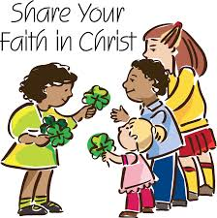

______________________________________________________________________________
Hamilton Diocesan Council
Of
The Catholic Women’s League of Canada
Care for Our Common Home
Name of Council: St. Mary of the Assumption, Owen Sound
Hamilton Diocesan Council
Of
The Catholic Women’s League of Canada
Care for Our Common Home
Name of President: Vicki Lee
Spiritual Advisor: Father Wojciech Kuzma
Number of members: 63 Life Members: 1

Greetings,

The council of St Mary of the Assumption did not meet during the 2021 year due to the Covid pandemic. We stayed connected using email. We were able to have Council elections at the end of the year and were able to elect a new President, Secretary, and Treasurer with other incumbent members being re-elected. We are slowly resuming our Council activities.

______________________________________________________________________________
Hamilton Diocesan Council
Of
The Catholic Women’s League of Canada
Care for Our Common Home
Name of Council: St. Joseph, Port Elgin
Hamilton Diocesan Council
Of
The Catholic Women’s League of Canada
Care for Our Common Home
Name of President: Lucie Desbiens
Spiritual Advisor: Father Christopher Tracey
Number of members: 58 Life Members: 0

Despite a second pandemic year, our Council kept busy. We held monthly Executive and General Meetings on Zoom. We were able to support several charitable causes as in previous years.
At the beginning of the pandemic, members of our council started a Tuesday evening Rosary for our personal intentions and for an end to the pandemic. This Rosary continues as we enter our 3rd year. We pray for ongoing world issues of today such as the war in the Ukraine. Our past President has held a weekly "Faith Sharing" with prayers and reflections of the upcoming Sunday readings.
A few of our members prepared and presented The Stations of the Cross during Lent 2021 with slide shows and prayers for this Friday Lenten devotion. This was offered for all parishioners to participate on Zoom.

One of our young members designed a Facebook page for our parish. CWL activities are posted keeping everyone informed with updates.

We held a 2021 Mother’s Day Raffle and raised $600 split between
Canadian Catholic Missions and Women's House of Grey Bruce. The beautiful basket was filled with donations from our ladies. The success of this event has prompted us to make the raffle happen again this year.
Many of our ladies took part in Teresa Hartnett’s webinars such as “Pope Francis’ encyclical Fratelli Tutti”, and the three part session on “Compassionate Care”.
A Time Capsule was put together to celebrate our parish’s 50th Anniversary in 2020. All groups, including the CWL, and some individuals contributed packages of information, photos and historical facts for the capsule that was sealed in February 2022. It will be opened in the year 2070.

Our ladies are involved in the Mass as Lectors, Greeters and Cleaners.

We have welcomed a few new members who have moved into our growing town. We patiently wait the day we can meet in person again.

______________________________________________________________________________
Hamilton Diocesan Council
Of
The Catholic Women’s League of Canada
Care for Our Common Home
Name of Council: Sacred Heart, Teeswater
Name of President: Jean Culliton
Spiritual Advisor: Father Michael Anderson/Father Paul Edmondstone
Number of members: 67 Life Members: 0
Hamilton Diocesan Council
Of
The Catholic Women’s League of Canada
Care for Our Common Home
After acquiring permission from our National CWL to use the CWL Logo, we
created a Closed Group Facebook Page, members only. Our executive
created a Rule Page and Facebook Page Policy Manual. We updated our
Policy and Procedures Manual also. Throughout the pandemic, Christian Family Life Chair, implemented “Care Call for Shut-ins”, a system that ensured those living alone and shut-in, receive a regular phone call of friendship.
We hosted a Virtual Lenten Retreat for our League sisters and surrounding
Leagues. A very special retreat with Teresa Hartnett giving a moving talk.
Monetary donations were made to Ramoth House, Wingham Right To Life
and World Day of Prayer.
Our Lady of Good Counsel was honoured with a Prayer Vigil April 25th. Pins
of Service were delivered to the doorsteps. No pictures for our History Book.
Even though we could not attend, Bibles were given to the Grade 5 students
specific for class studies, gifts to First Communicants, Confirmation
Candidates and Graduation Students.
A Swiss Chalet Takeout Dinner Fundraiser was held in June. Minimal CWL
members were needed, while still able to help our depleting bank account.
“Toonies Together”, as it sounds, throw your toonies in the jar at Church. “A
Food Security” project to purchase meat for families in need. Our CWL gave
a kick start to our fundraiser with a donation of $500. Food security is a
yearly project of our League.
In honour of Our Blessed Mother Mary, league members led the Rosary
before Sunday Mass during the month of October. To commemorate our CWL 100th Anniversary, a tree was planted by a League member, her husband and 2 sons as restrictions did not allow gatherings. The chosen tree is a Rose of Sharon.
Our Christmas Project, beautiful blue on white lawn signs “Keep Christ In
Christmas”, adorned our lawns. A wonderful idea by our Spiritual Chair.
I am very proud of our League for “thinking outside the box” to find a way to
help others during this Covid Pandemic when caring was most needed.

______________________________________________________________________________
Hamilton Diocesan Council
Of
The Catholic Women’s League of Canada
Care for Our Common Home
Name of Council: Sacred Heart Parish, Walkerton
Name of President: Deborah Hicks
Spiritual Advisor: Father Leszek Szczygiel
Number of members: 141 Life Members: 0

2021 was a long year with many meetings having to be cancelled. We were able to hold a regular meeting in March and December. We were not able to host any funeral luncheons. (As of April 7, 2022 we are back in business!)
Our ladies organized a roast beef drive through dinner. With the expertise of minimal staff in the kitchen we were able to prepare approximately 170 meals. We had quite the assembly line packaging the meals. The runners then delivered the bags to the long line of cars that pulled up in front of the church. It was definitely a happening event! It was a successful fundraiser for us. We were able to contribute to all of our donation responsibilities and pay our expenses for the year. Our end of year balance is not as high as other years but we have great plans for the upcoming year!

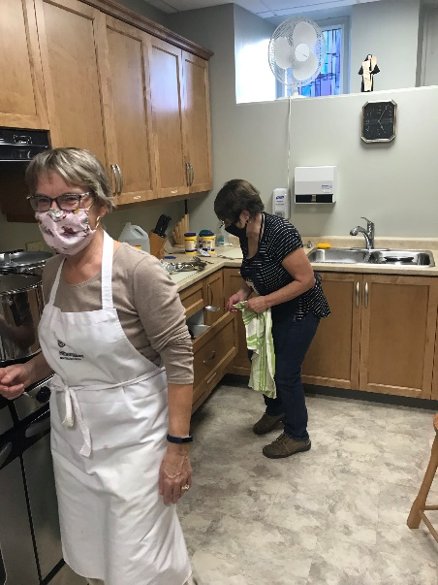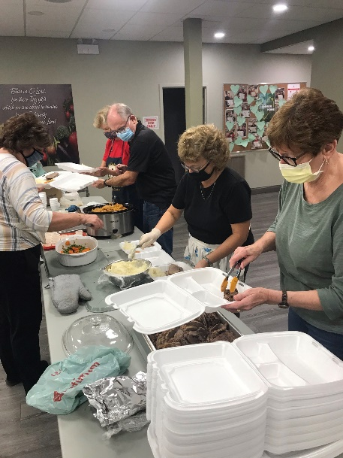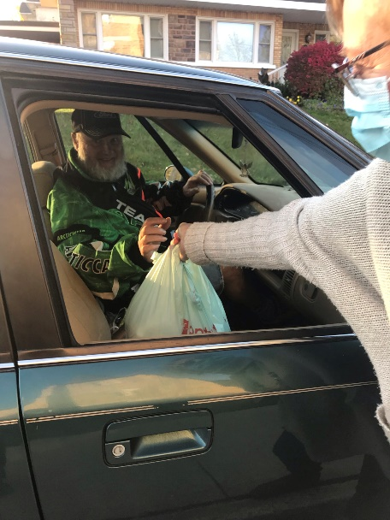

______________________________________________________________________________
Hamilton Diocesan Council
Of
The Catholic Women’s League of Canada
Care for Our Common Home
Name of Council: St. Thomas Aquinas, Wiarton
Hamilton Diocesan Council
Of
The Catholic Women’s League of Canada
Care for Our Common Home
Name of President: Ruth Ditner
Spiritual Advisor: Deacon Philip Dwyer
Number of members: 27 Life Members: 0

During 2021 we held one outdoor activity. It was a plant/garage sale. Perennials were ready for thinning and transplanting. Names and indication if the plant thrived in the sun or shade were offered. Garage items consisted of books, games, puzzles, dishes and decor items. Our League donated $350.00 to the Salvation Army who support our community and surrounding area. It was a fun day for the members and I am grateful for the outcome.

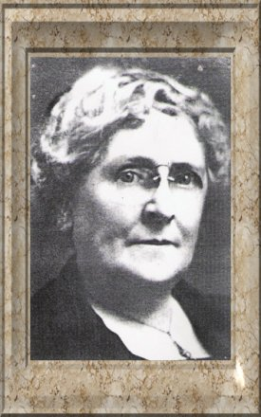
1st Hamilton Diocesan President

Frances Lovering, the First Hamilton Diocesan President from 1920 – 1923 was an active member of St. Joseph’s and St. Mary’s Parish churches in Hamilton where she had been Parish President.
Frances Lovering along with Miss Florence Barker helped organize the Catholic Women’s Guild of Hamilton in 1917 to care for the religious needs of Catholic soldiers. This Guild was later formed into the Catholic Women’s League of Hamilton Diocese in September 1920.

Frances became the 1st National CWL Treasurer in 1920. In 1923 – 1925, Frances was elected the National CWL President.

For Frances the CWL provided a public voice on matters that affected all women and Catholics in particular. She became an advocate for humane and social welfare; formed a branch of Secours National that sent trucks, cases of food, clothing and hospital supplies to soldiers and their families in France; organized aid to the underprivileged in France; provided aid to the elderly, ill and physically disabled travelers, and volunteered for social agencies such as Big Sisters’ Association, Children’s Aid Society etc.
Frances received the Medal of Honor (1917) and Medal of Reconnaissance Francaise (1921) from the French government for her work on behalf of Secours National; for her religious work the papacy gave her the Medal Pro Ecclesia et Pontifice (1925) and Mesaglia Benemerenti (1926). Shortly after her death (March 26, 1926) she was made a chevalier of France’s Legion of Honour, the only woman in Canada to have been granted this tribute.
A “Frances Lovering Bursary” was established in 1996 at St. Jerome’ University. For our 75th anniversary year of the League, a memorial gravestone marker was placed at Frances’ gravesite in Hamilton.

Hamilton Diocesan Council
of
The Catholic Women’s League of Canada

Care for Our Common Home

FRANCES LOVERING WOMAN OF THE YEAR AWARD
In the year 2000, as a Millennium Project, the diocesan executive initiated the Woman of the Year Award. This award is named to honour Frances Lovering, a member of the first executive of Catholic Women's League of Canada, and our first diocesan president. Here is a list of our past recipients:
2019 Bonita Jones St. Mary of the Assumption, Owen Sound
2018 Maria Theresia Burgund St. Aloysius, Kitchener
2017 Anna Rettinger St. Andrew, Oakville
2016 Lillian Orzel St. Luke, Hamilton
2015 Barbara Diemert St. Francis of Assisi, Kitchener
2014 Anne Rehkopf Holy Family, Hanover
2013 Elsie Hankinson St. Pius, Brantford
2012 Helen Kurtz Christie St. Joseph, Guelph
2011 Noreen Miehm Holy Cross, Georgetown
2010 Barbara Bishop Holy Rosary, Guelph
2009 Anne Marie Sehl St. Agnes, Waterloo
2008 Marian Flanigan St. Mary of the Purification, Mount Forest
2007 Nancy Morley St. Luke, Hamilton
2006 Margaret Synnott St. Joseph, Guelph
2005 Rita Bradbury St. Gabriel, Burlington
2004 Dorothy Farwell Sacred Heart, Kitchener
2003 Mary Elizabeth Codnich Regina Mundi, Hamilton
2002 Betty Dietrich St. John, Kitchener
2001 Siena Van Hoekelin Holy Cross, Georgetown
2000 Ann Brown St. John, Arthur

Congratulations to all our past recipients and the 2020, 2021 award winner will be presented her award at the next convention.

100+ Anniversary Celebration
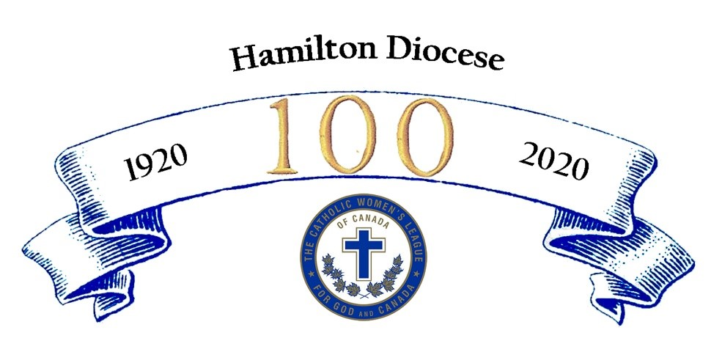

We celebrate 100+ years of The Catholic Women’s League of Canada in the Diocese of Hamilton. What a journey we have travelled together in living out our mission statement. Through God’s grace, members have shared their gifts in their parish, community, diocese, province, across Canada and throughout the world.
And it all began when 15 women from different parishes met to discuss the advisability of forming a society to care for the religious needs of Catholic soldiers quartered in Hamilton and for the soldiers in sanatoriums and hospitals. It was called "The Catholic Women’s Guild” with Rose Smith as President and Monsignor Mahony as Chaplain in 1917.
In June 1920, President Frances Lovering and Secretary Mrs. F.E. Regan were invited to attend a meeting held in Montreal for all the local societies from across Canada. This is where the National League came into existence with its own set of Constitution and By-laws.
After their return home, in September 1920, they asked that the name of The Catholic Women’s Guild be changed to The Catholic Women’s League of Canada and so it all began. We started with 11 sub-divisions (councils). Today we have 93 parish councils, 4 regions: Brant, Hamilton, Kitchener, North and 6,021 members. Slightly less than at our highest membership count of 14, 440 members with 98 councils in 1978.
Let us remind the women of our parish, the League is not like any other club or organization. The League is women of shared beliefs expressing their faith through community and sisterhood.
We pray together, laugh together, and encourage each other in roles of ministry. We support leadership by serving on school boards, hospital boards, teaching night school to new immigrants.
We walked for peace in 1962, supplied mass kits to ships at sea, make rosaries for First Communion students, prayed 12 hours for palliative care, celebrated special masses for our deceased members, World day of Prayer, and vocations to the Priesthood to name a few.
Members supplied surgical dressings to military hospitals, gave food and medicine to school children, sewed masks and protective gowns for front line workers. Donated to food banks, collected 10,523 socks for the homeless, and raised $16,000 for the rebuilding of a church in Whitehorse, B.C.
The League became the public voice promoting Christian family values and upholding the life and dignity of human persons. We gathered signatures for the “Petition of One Million” against abortion, promoted foster homes, boycotted buying products produced under bad working conditions by underpaid workers, wrote letters in protest of euthanasia and assisted suicide.
We’ve raised awareness of the additive influence of pornography and its destructive effect on children, marriage and families through our “Pornography Hurts” campaign which was launched in 1996. Letters/postcards were sent to Members of Parliament, signs were posted on transit buses, and you can still view the billboard outside Walkerton.
Through our “Resolutions”, we raised awareness on poverty, nuclear arms, elder abuse, mental health, reduce-reuse-recycle, plastic microbeads and the high cost of beauty. Two hundred and thirteen resolutions have been passed in Hamilton Diocese, the first resolution was presented in 1933.
In celebration of 100 years of the League, we planted trees, wrote a prayer for our anniversary prayer book, participated in the scavenger hunt guessing games of whose parish is this, and served the community in a special project.
May this remarkable legacy of service inspire you to continue working to grow in faith and to witness to the love of God through ministry in the parish, community and diocese.

