Along with our Provincial Spiritual Advisor and Diocesan Spiritual Advisors
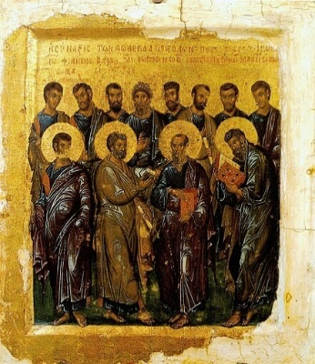
Invites You
This Photo by Unknown Author is licensed under CC BY-SA
To a Virtual Prayer Service for the intention of
all our Spiritual Advisors, Priests
and Vocations
December 11, 2023
7:00pm

Please register to attend using the link below:

https://us06web.zoom.us/meeting/register/tZMvdOqurjovGNx1leK4M8Osjnf7cCW4gmuP

