 | Hamilton Diocesan Council  of  The Catholic Women’s League of Canada    Sparkle God’s Way!  Be A Beacon of HOPE and LIGHT to Everyone You Meet | 

LIFE MEMBER CONVENTION INCENTIVE FUND

CRITERIA

This fund has been created to encourage members to attend the Hamilton Diocesan Annual Convention.

Applicants for this fund are:

a) A member whose membership has been paid for the present year
b) A member interested in learning more about the Catholic Woman’s League
c) A first-time attendee to a diocesan convention
d) A member who has submitted her registration for the convention
e) A member who is not a parish president
f) A member who is not a voting delegate

One application for each parish council per year will be considered. Please ensure that the application has been signed by the applicant and parish council president.

The sum up to $200.00 will be awarded to go towards the cost of hotel accommodation, meals, and bus transportation to and from the opening and closing liturgies for each recipient.

HAMILTON DIOCESE

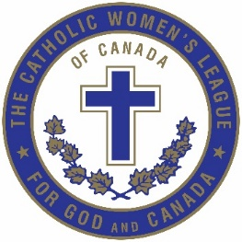
LIFE MEMBER CONVENTION INCENTIVE FUND

APPLICATION FORM
PLEASE PRINT CLEARLY

Member’s Name:

Address:

City:

Phone Number:

Email Address:

Parish Council (include city):

I affirm that I am applying for the LIFE MEMBER CONVENTION INCENTIVE FUND.
I have paid my membership for 2025 to the parish council.
I am not attending the convention as a voting delegate.
I have not attended a Diocesan convention in the past.

Member’s signature:

I affirm that the applicant has paid her membership for the year 2025.
I affirm that our membership fees have been sent into the National office for processing.

I endorse this applicant for the LIFE MEMBER CONVENTION INCENTIVE FUND.

Parish President’s Signature:


All applications are to be submitted to convention co-chair Joan Schurter via email by the convention registration deadline of May 5, 2025: lifememberliaison1cwlhamilton@gmail.com

