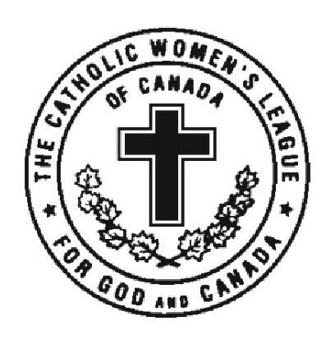**Registration Form**

**The Hamilton Diocesan Council of the Catholic Women’s League of Canada**

**105th Annual Convention**

May 30 – June 1, 2025

Holiday Inn / Candlewood Suites Burlington Hotel & Conference Centre 3063 South Service Road, Burlington, ON L7N 3E9

Registration Deadline – **May 5, 2025 Please complete all areas of the form.**

Name ______________________________________________________________________________

Address _____________________________________________________________________________

City/Town __________________________________________ Postal Code _______________________

Telephone ( ) ____________________ Email Address _______________________________________

Region ____ Brant ____ Hamilton ____ Kitchener ____ North

City _______________________ Parish Council _____________________________________________

This is my first diocesan convention. ____ Yes ____ No

Please check ***only one item*** in this section

I am attending this convention as a:

|  |  |  |
| --- | --- | --- |
|  | **Voting** **Delegate** (Parish President or delegate) | Attach credentials form |
|  | **Parish** **Accredited** Delegate | Attach credentials form |
|  | **Diocesan Officer** | Attach credentials form |
|  | **Life Member** | Attach credentials form |

**Non**-**Voting** attendees:

|  |  |
| --- | --- |
|  | Diocesan Spiritual Advisor |
|  | Parish Council Spiritual Advisor |
|  | Catholic Women’s League Member |
|  | National Representative |
|  | Provincial Representative |
|  | Member of the Hierarchy |
|  | Guest |

I will be attending these events: (select all that apply)

____ Friday Presidents’ Pre-convention Meeting ____ Saturday Sessions

____ Friday Workshop ____ Sunday Sessions

____ Friday Spiritual Advisors’ Meeting ____ Sunday Banquet Only

**Please complete forms online:** [**www.cwlhamilton.ca**](http://www.cwlhamilton.ca)

***OR* mail to: Joanne Gregson 80-6478 5th Line Fergus, ON N1M 2W5**

**This Convention is a *SCENT FREE* event. Help us keep the air we share healthy and enjoyable for ALL!**

***OR* scan and email to Joanne Gregson at** [**joannegregson57@gmail.com**](mailto:joannegregson57@gmail.com)